1 run......

training 1 epoch...

10.508601665496826 seconds used......

1 training finished! average train loss: 0.7568245750207168

evaluating...

Confusion matrix, without normalization

[[ 0 0 41]

[ 0 0 95]

[ 0 0 714]]

Normalized confusion matrix

[[0. 0. 1.]

[0. 0. 1.]

[0. 0. 1.]]

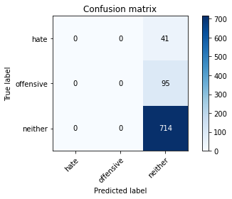

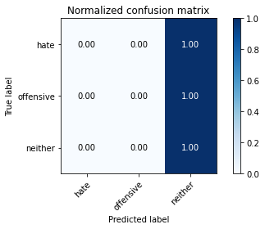

/opt/conda/lib/python3.7/site-packages/sklearn/metrics/_classification.py:1245: UndefinedMetricWarning: Precision and F-score are ill-defined and being set to 0.0 in labels with no predicted samples. Use `zero_division` parameter to control this behavior.

_warn_prf(average, modifier, msg_start, len(result))

/opt/conda/lib/python3.7/site-packages/sklearn/metrics/_classification.py:1245: UndefinedMetricWarning: Precision and F-score are ill-defined and being set to 0.0 in labels with no predicted samples. Use `zero_division` parameter to control this behavior.

_warn_prf(average, modifier, msg_start, len(result))

/opt/conda/lib/python3.7/site-packages/sklearn/metrics/_classification.py:1245: UndefinedMetricWarning: Precision and F-score are ill-defined and being set to 0.0 in labels with no predicted samples. Use `zero_division` parameter to control this behavior.

_warn_prf(average, modifier, msg_start, len(result))

precision recall f1-score support

hate 0.00 0.00 0.00 41

offensive 0.00 0.00 0.00 95

neither 0.84 1.00 0.91 714

accuracy 0.84 850

macro avg 0.28 0.33 0.30 850

weighted avg 0.71 0.84 0.77 850

average eval_loss: 0.5626876482436823, accuracy: 0.84

training 2 epoch...

10.541451215744019 seconds used......

2 training finished! average train loss: 0.6421507821633266

evaluating...

Confusion matrix, without normalization

[[ 3 1 37]

[ 4 0 91]

[ 7 2 705]]

Normalized confusion matrix

[[0.07317073 0.02439024 0.90243902]

[0.04210526 0. 0.95789474]

[0.00980392 0.00280112 0.98739496]]

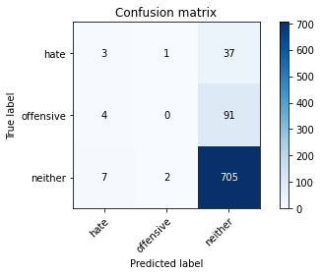

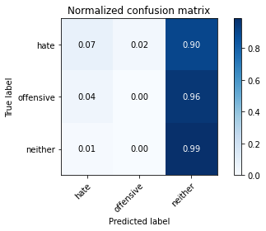

precision recall f1-score support

hate 0.21 0.07 0.11 41

offensive 0.00 0.00 0.00 95

neither 0.85 0.99 0.91 714

accuracy 0.83 850

macro avg 0.35 0.35 0.34 850

weighted avg 0.72 0.83 0.77 850

average eval_loss: 0.46358234426656436, accuracy: 0.8329411764705882

training 3 epoch...

10.508302211761475 seconds used......

3 training finished! average train loss: 0.47660040351060723

evaluating...

Confusion matrix, without normalization

[[ 5 6 30]

[ 4 11 80]

[ 13 25 676]]

Normalized confusion matrix

[[0.12195122 0.14634146 0.73170732]

[0.04210526 0.11578947 0.84210526]

[0.01820728 0.03501401 0.94677871]]

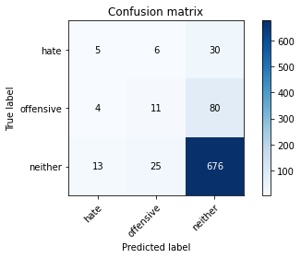

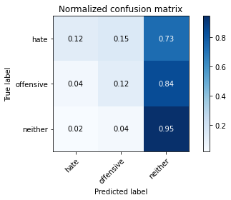

precision recall f1-score support

hate 0.23 0.12 0.16 41

offensive 0.26 0.12 0.16 95

neither 0.86 0.95 0.90 714

accuracy 0.81 850

macro avg 0.45 0.39 0.41 850

weighted avg 0.76 0.81 0.78 850

average eval_loss: 0.48671663340267746, accuracy: 0.8141176470588235

training 4 epoch...

10.518319606781006 seconds used......

4 training finished! average train loss: 0.2934503157551472

evaluating...

Confusion matrix, without normalization

[[ 10 10 21]

[ 11 36 48]

[ 36 84 594]]

Normalized confusion matrix

[[0.24390244 0.24390244 0.51219512]

[0.11578947 0.37894737 0.50526316]

[0.05042017 0.11764706 0.83193277]]

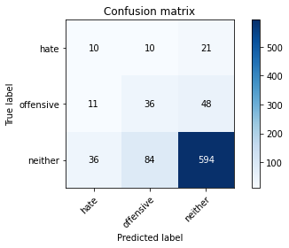

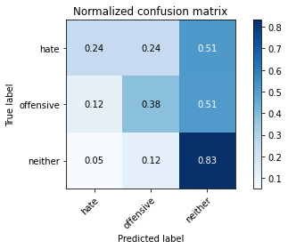

precision recall f1-score support

hate 0.18 0.24 0.20 41

offensive 0.28 0.38 0.32 95

neither 0.90 0.83 0.86 714

accuracy 0.75 850

macro avg 0.45 0.48 0.46 850

weighted avg 0.79 0.75 0.77 850

average eval_loss: 0.6037907261444733, accuracy: 0.7529411764705882

training 5 epoch...

10.498871564865112 seconds used......

5 training finished! average train loss: 0.15491789006269896

evaluating...

Confusion matrix, without normalization

[[ 7 5 29]

[ 5 23 67]

[ 17 54 643]]

Normalized confusion matrix

[[0.17073171 0.12195122 0.70731707]

[0.05263158 0.24210526 0.70526316]

[0.02380952 0.07563025 0.90056022]]

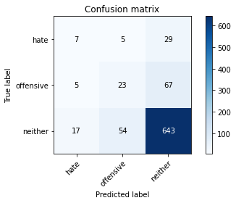

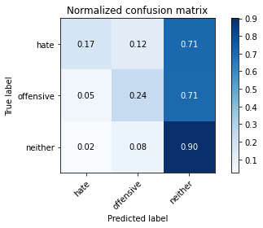

precision recall f1-score support

hate 0.24 0.17 0.20 41

offensive 0.28 0.24 0.26 95

neither 0.87 0.90 0.89 714

accuracy 0.79 850

macro avg 0.46 0.44 0.45 850

weighted avg 0.77 0.79 0.78 850

average eval_loss: 0.6696944703012272, accuracy: 0.7917647058823529

training 6 epoch...

10.552352666854858 seconds used......

6 training finished! average train loss: 0.07080833903298928

evaluating...

Confusion matrix, without normalization

[[ 12 6 23]

[ 13 26 56]

[ 36 72 606]]

Normalized confusion matrix

[[0.29268293 0.14634146 0.56097561]

[0.13684211 0.27368421 0.58947368]

[0.05042017 0.10084034 0.8487395 ]]

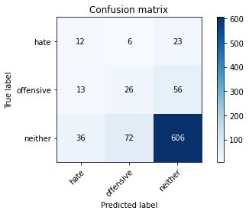

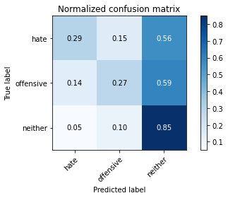

precision recall f1-score support

hate 0.20 0.29 0.24 41

offensive 0.25 0.27 0.26 95

neither 0.88 0.85 0.87 714

accuracy 0.76 850

macro avg 0.44 0.47 0.45 850

weighted avg 0.78 0.76 0.77 850

average eval_loss: 0.8361571589593104, accuracy: 0.7576470588235295

training 7 epoch...

10.601153135299683 seconds used......

7 training finished! average train loss: 0.03661658101930068

evaluating...

Confusion matrix, without normalization

[[ 3 13 25]

[ 3 30 62]

[ 14 90 610]]

Normalized confusion matrix

[[0.07317073 0.31707317 0.6097561 ]

[0.03157895 0.31578947 0.65263158]

[0.01960784 0.12605042 0.85434174]]

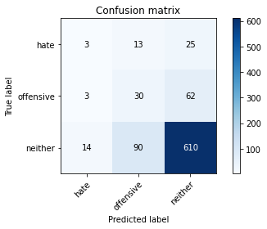

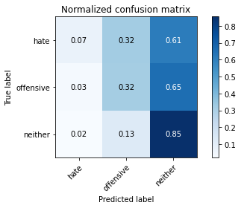

precision recall f1-score support

hate 0.15 0.07 0.10 41

offensive 0.23 0.32 0.26 95

neither 0.88 0.85 0.86 714

accuracy 0.76 850

macro avg 0.42 0.41 0.41 850

weighted avg 0.77 0.76 0.76 850

average eval_loss: 0.9627218077035058, accuracy: 0.7564705882352941

training 8 epoch...

10.568329095840454 seconds used......

8 training finished! average train loss: 0.022611002849701505

evaluating...

Confusion matrix, without normalization

[[ 2 13 26]

[ 2 27 66]

[ 8 82 624]]

Normalized confusion matrix

[[0.04878049 0.31707317 0.63414634]

[0.02105263 0.28421053 0.69473684]

[0.01120448 0.11484594 0.87394958]]

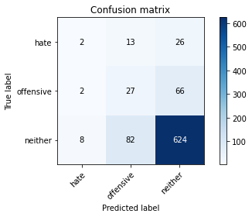

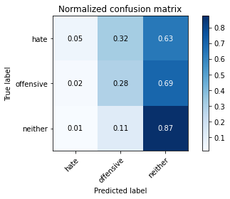

precision recall f1-score support

hate 0.17 0.05 0.08 41

offensive 0.22 0.28 0.25 95

neither 0.87 0.87 0.87 714

accuracy 0.77 850

macro avg 0.42 0.40 0.40 850

weighted avg 0.76 0.77 0.76 850

average eval_loss: 0.9982702426319985, accuracy: 0.768235294117647

training 9 epoch...

10.615682125091553 seconds used......

9 training finished! average train loss: 0.012070468512292092

evaluating...

Confusion matrix, without normalization

[[ 3 15 23]

[ 2 33 60]

[ 13 95 606]]

Normalized confusion matrix

[[0.07317073 0.36585366 0.56097561]

[0.02105263 0.34736842 0.63157895]

[0.01820728 0.13305322 0.8487395 ]]

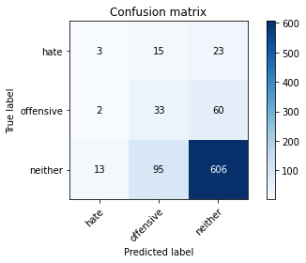

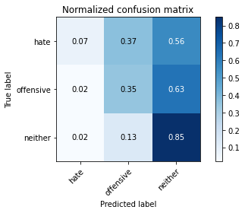

precision recall f1-score support

hate 0.17 0.07 0.10 41

offensive 0.23 0.35 0.28 95

neither 0.88 0.85 0.86 714

accuracy 0.76 850

macro avg 0.43 0.42 0.41 850

weighted avg 0.77 0.76 0.76 850

average eval_loss: 1.1165478747428752, accuracy: 0.7552941176470588

training 10 epoch...

10.547589778900146 seconds used......

10 training finished! average train loss: 0.005783453966096903

evaluating...

Confusion matrix, without normalization

[[ 5 15 21]

[ 6 34 55]

[ 20 98 596]]

Normalized confusion matrix

[[0.12195122 0.36585366 0.51219512]

[0.06315789 0.35789474 0.57894737]

[0.0280112 0.1372549 0.83473389]]

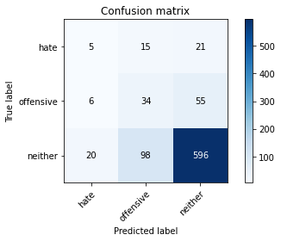

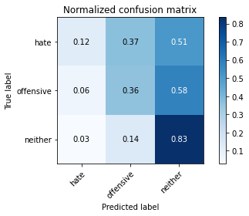

precision recall f1-score support

hate 0.16 0.12 0.14 41

offensive 0.23 0.36 0.28 95

neither 0.89 0.83 0.86 714

accuracy 0.75 850

macro avg 0.43 0.44 0.43 850

weighted avg 0.78 0.75 0.76 850

average eval_loss: 1.1964415907243884, accuracy: 0.7470588235294118

training 11 epoch...

10.637108325958252 seconds used......

11 training finished! average train loss: 0.0041061610896856735

evaluating...

Confusion matrix, without normalization

[[ 2 15 24]

[ 2 29 64]

[ 8 87 619]]

Normalized confusion matrix

[[0.04878049 0.36585366 0.58536585]

[0.02105263 0.30526316 0.67368421]

[0.01120448 0.12184874 0.86694678]]

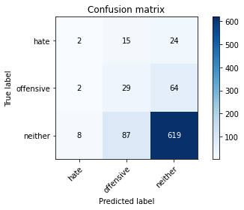

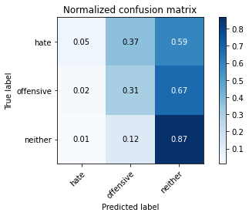

precision recall f1-score support

hate 0.17 0.05 0.08 41

offensive 0.22 0.31 0.26 95

neither 0.88 0.87 0.87 714

accuracy 0.76 850

macro avg 0.42 0.41 0.40 850

weighted avg 0.77 0.76 0.76 850

average eval_loss: 1.1933606269496606, accuracy: 0.7647058823529411

training 12 epoch...

10.534799337387085 seconds used......

12 training finished! average train loss: 0.0068177149720633256

evaluating...

Confusion matrix, without normalization

[[ 4 6 31]

[ 4 23 68]

[ 14 57 643]]

Normalized confusion matrix

[[0.09756098 0.14634146 0.75609756]

[0.04210526 0.24210526 0.71578947]

[0.01960784 0.07983193 0.90056022]]

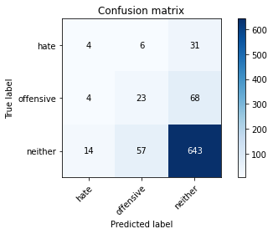

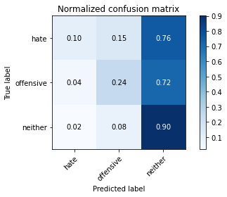

precision recall f1-score support

hate 0.18 0.10 0.13 41

offensive 0.27 0.24 0.25 95

neither 0.87 0.90 0.88 714

accuracy 0.79 850

macro avg 0.44 0.41 0.42 850

weighted avg 0.77 0.79 0.78 850

average eval_loss: 1.148611023419213, accuracy: 0.788235294117647

training 13 epoch...

10.561787605285645 seconds used......

13 training finished! average train loss: 0.001969915736789027

evaluating...

Confusion matrix, without normalization

[[ 0 13 28]

[ 2 30 63]

[ 10 73 631]]

Normalized confusion matrix

[[0. 0.31707317 0.68292683]

[0.02105263 0.31578947 0.66315789]

[0.0140056 0.1022409 0.8837535 ]]

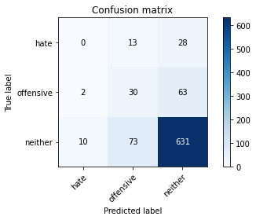

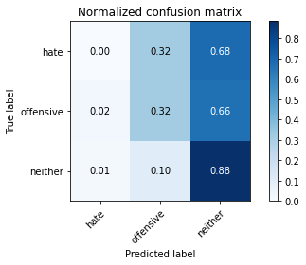

precision recall f1-score support

hate 0.00 0.00 0.00 41

offensive 0.26 0.32 0.28 95

neither 0.87 0.88 0.88 714

accuracy 0.78 850

macro avg 0.38 0.40 0.39 850

weighted avg 0.76 0.78 0.77 850

average eval_loss: 1.2214558111839768, accuracy: 0.7776470588235294

training 14 epoch...

10.568328857421875 seconds used......

14 training finished! average train loss: 0.001640259084972338

evaluating...

Confusion matrix, without normalization

[[ 2 13 26]

[ 4 42 49]

[ 11 99 604]]

Normalized confusion matrix

[[0.04878049 0.31707317 0.63414634]

[0.04210526 0.44210526 0.51578947]

[0.01540616 0.13865546 0.84593838]]

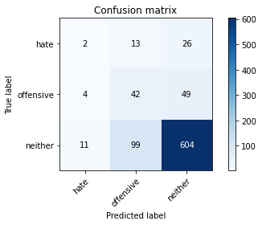

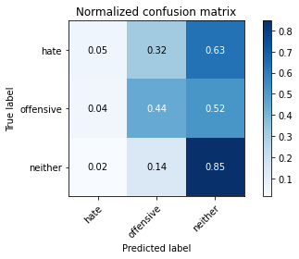

precision recall f1-score support

hate 0.12 0.05 0.07 41

offensive 0.27 0.44 0.34 95

neither 0.89 0.85 0.87 714

accuracy 0.76 850

macro avg 0.43 0.45 0.42 850

weighted avg 0.78 0.76 0.77 850

average eval_loss: 1.2393101906382917, accuracy: 0.7623529411764706

training 15 epoch...

10.549166440963745 seconds used......

15 training finished! average train loss: 0.0013982651193285933

evaluating...

Confusion matrix, without normalization

[[ 2 16 23]

[ 4 44 47]

[ 11 105 598]]

Normalized confusion matrix

[[0.04878049 0.3902439 0.56097561]

[0.04210526 0.46315789 0.49473684]

[0.01540616 0.14705882 0.83753501]]

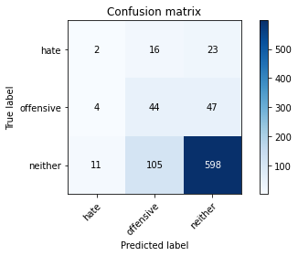

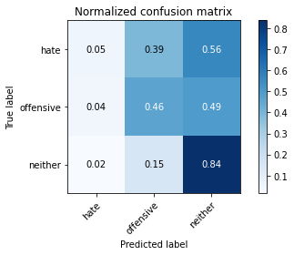

precision recall f1-score support

hate 0.12 0.05 0.07 41

offensive 0.27 0.46 0.34 95

neither 0.90 0.84 0.87 714

accuracy 0.76 850

macro avg 0.43 0.45 0.42 850

weighted avg 0.79 0.76 0.77 850

average eval_loss: 1.3241254969997138, accuracy: 0.7576470588235295

training 16 epoch...

10.624794244766235 seconds used......

16 training finished! average train loss: 0.000978640078056532

evaluating...

Confusion matrix, without normalization

[[ 1 15 25]

[ 4 45 46]

[ 6 104 604]]

Normalized confusion matrix

[[0.02439024 0.36585366 0.6097561 ]

[0.04210526 0.47368421 0.48421053]

[0.00840336 0.14565826 0.84593838]]

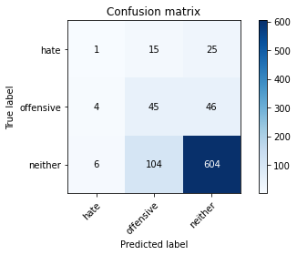

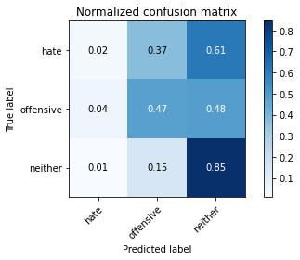

precision recall f1-score support

hate 0.09 0.02 0.04 41

offensive 0.27 0.47 0.35 95

neither 0.89 0.85 0.87 714

accuracy 0.76 850

macro avg 0.42 0.45 0.42 850

weighted avg 0.79 0.76 0.77 850

average eval_loss: 1.2982540471410091, accuracy: 0.7647058823529411

training 17 epoch...

10.54309892654419 seconds used......

17 training finished! average train loss: 0.0007009334893574795

evaluating...

Confusion matrix, without normalization

[[ 0 11 30]

[ 1 35 59]

[ 2 82 630]]

Normalized confusion matrix

[[0. 0.26829268 0.73170732]

[0.01052632 0.36842105 0.62105263]

[0.00280112 0.11484594 0.88235294]]

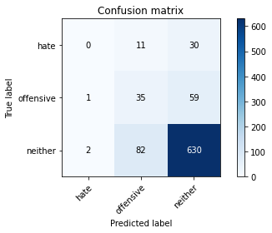

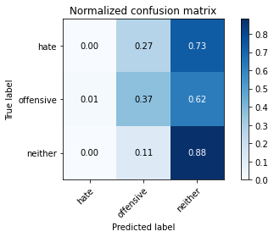

precision recall f1-score support

hate 0.00 0.00 0.00 41

offensive 0.27 0.37 0.31 95

neither 0.88 0.88 0.88 714

accuracy 0.78 850

macro avg 0.38 0.42 0.40 850

weighted avg 0.77 0.78 0.77 850

average eval_loss: 1.2674321853246935, accuracy: 0.7823529411764706

training 18 epoch...

10.664237976074219 seconds used......

18 training finished! average train loss: 0.0004986101230875087

evaluating...

Confusion matrix, without normalization

[[ 4 11 26]

[ 4 35 56]

[ 12 86 616]]

Normalized confusion matrix

[[0.09756098 0.26829268 0.63414634]

[0.04210526 0.36842105 0.58947368]

[0.01680672 0.12044818 0.8627451 ]]

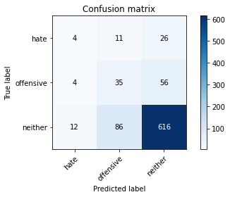

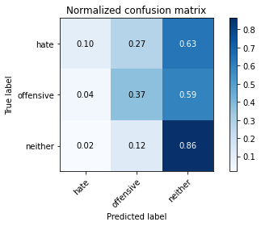

precision recall f1-score support

hate 0.20 0.10 0.13 41

offensive 0.27 0.37 0.31 95

neither 0.88 0.86 0.87 714

accuracy 0.77 850

macro avg 0.45 0.44 0.44 850

weighted avg 0.78 0.77 0.77 850

average eval_loss: 1.2591802248250534, accuracy: 0.7705882352941177

training 19 epoch...

10.530650854110718 seconds used......

19 training finished! average train loss: 0.007468740543341622

evaluating...

Confusion matrix, without normalization

[[ 8 5 28]

[ 5 23 67]

[ 20 53 641]]

Normalized confusion matrix

[[0.19512195 0.12195122 0.68292683]

[0.05263158 0.24210526 0.70526316]

[0.0280112 0.07422969 0.8977591 ]]

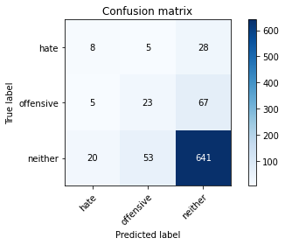

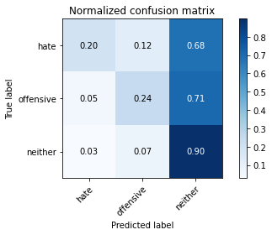

precision recall f1-score support

hate 0.24 0.20 0.22 41

offensive 0.28 0.24 0.26 95

neither 0.87 0.90 0.88 714

accuracy 0.79 850

macro avg 0.47 0.44 0.45 850

weighted avg 0.78 0.79 0.78 850

average eval_loss: 1.128772520251047, accuracy: 0.7905882352941176

training 20 epoch...

10.576409339904785 seconds used......

20 training finished! average train loss: 0.009404772053284643

evaluating...

Confusion matrix, without normalization

[[ 9 5 27]

[ 13 30 52]

[ 43 50 621]]

Normalized confusion matrix

[[0.2195122 0.12195122 0.65853659]

[0.13684211 0.31578947 0.54736842]

[0.06022409 0.07002801 0.8697479 ]]

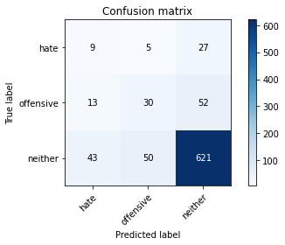

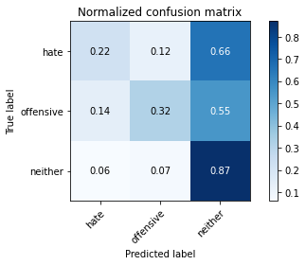

precision recall f1-score support

hate 0.14 0.22 0.17 41

offensive 0.35 0.32 0.33 95

neither 0.89 0.87 0.88 714

accuracy 0.78 850

macro avg 0.46 0.47 0.46 850

weighted avg 0.79 0.78 0.78 850

average eval_loss: 1.099467357095036, accuracy: 0.7764705882352941

2 run......

training 1 epoch...

10.548880577087402 seconds used......

1 training finished! average train loss: 0.8044887639009035

evaluating...

Confusion matrix, without normalization

[[ 0 0 41]

[ 0 0 95]

[ 0 0 714]]

Normalized confusion matrix

[[0. 0. 1.]

[0. 0. 1.]

[0. 0. 1.]]





/opt/conda/lib/python3.7/site-packages/sklearn/metrics/_classification.py:1245: UndefinedMetricWarning: Precision and F-score are ill-defined and being set to 0.0 in labels with no predicted samples. Use `zero_division` parameter to control this behavior.

_warn_prf(average, modifier, msg_start, len(result))

/opt/conda/lib/python3.7/site-packages/sklearn/metrics/_classification.py:1245: UndefinedMetricWarning: Precision and F-score are ill-defined and being set to 0.0 in labels with no predicted samples. Use `zero_division` parameter to control this behavior.

_warn_prf(average, modifier, msg_start, len(result))

/opt/conda/lib/python3.7/site-packages/sklearn/metrics/_classification.py:1245: UndefinedMetricWarning: Precision and F-score are ill-defined and being set to 0.0 in labels with no predicted samples. Use `zero_division` parameter to control this behavior.

_warn_prf(average, modifier, msg_start, len(result))

precision recall f1-score support

hate 0.00 0.00 0.00 41

offensive 0.00 0.00 0.00 95

neither 0.84 1.00 0.91 714

accuracy 0.84 850

macro avg 0.28 0.33 0.30 850

weighted avg 0.71 0.84 0.77 850

average eval_loss: 0.5837117922167445, accuracy: 0.84

training 2 epoch...

10.55309772491455 seconds used......

2 training finished! average train loss: 0.6801925466610835

evaluating...

Confusion matrix, without normalization

[[ 1 0 40]

[ 0 0 95]

[ 4 0 710]]

Normalized confusion matrix

[[0.02439024 0. 0.97560976]

[0. 0. 1. ]

[0.00560224 0. 0.99439776]]

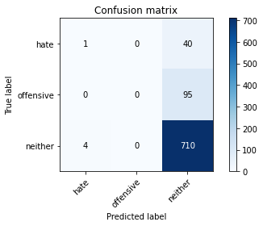

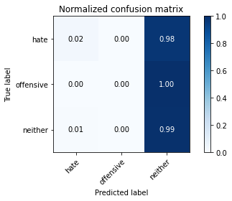

/opt/conda/lib/python3.7/site-packages/sklearn/metrics/_classification.py:1245: UndefinedMetricWarning: Precision and F-score are ill-defined and being set to 0.0 in labels with no predicted samples. Use `zero_division` parameter to control this behavior.

_warn_prf(average, modifier, msg_start, len(result))

/opt/conda/lib/python3.7/site-packages/sklearn/metrics/_classification.py:1245: UndefinedMetricWarning: Precision and F-score are ill-defined and being set to 0.0 in labels with no predicted samples. Use `zero_division` parameter to control this behavior.

_warn_prf(average, modifier, msg_start, len(result))

/opt/conda/lib/python3.7/site-packages/sklearn/metrics/_classification.py:1245: UndefinedMetricWarning: Precision and F-score are ill-defined and being set to 0.0 in labels with no predicted samples. Use `zero_division` parameter to control this behavior.

_warn_prf(average, modifier, msg_start, len(result))

precision recall f1-score support

hate 0.20 0.02 0.04 41

offensive 0.00 0.00 0.00 95

neither 0.84 0.99 0.91 714

accuracy 0.84 850

macro avg 0.35 0.34 0.32 850

weighted avg 0.72 0.84 0.77 850

average eval_loss: 0.5106648316736832, accuracy: 0.8364705882352941

training 3 epoch...

10.57227087020874 seconds used......

3 training finished! average train loss: 0.569850130035327

evaluating...

Confusion matrix, without normalization

[[ 12 0 29]

[ 4 0 91]

[ 18 0 696]]

Normalized confusion matrix

[[0.29268293 0. 0.70731707]

[0.04210526 0. 0.95789474]

[0.02521008 0. 0.97478992]]

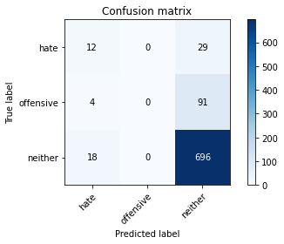

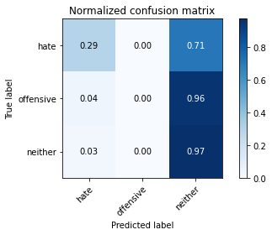

/opt/conda/lib/python3.7/site-packages/sklearn/metrics/_classification.py:1245: UndefinedMetricWarning: Precision and F-score are ill-defined and being set to 0.0 in labels with no predicted samples. Use `zero_division` parameter to control this behavior.

_warn_prf(average, modifier, msg_start, len(result))

/opt/conda/lib/python3.7/site-packages/sklearn/metrics/_classification.py:1245: UndefinedMetricWarning: Precision and F-score are ill-defined and being set to 0.0 in labels with no predicted samples. Use `zero_division` parameter to control this behavior.

_warn_prf(average, modifier, msg_start, len(result))

/opt/conda/lib/python3.7/site-packages/sklearn/metrics/_classification.py:1245: UndefinedMetricWarning: Precision and F-score are ill-defined and being set to 0.0 in labels with no predicted samples. Use `zero_division` parameter to control this behavior.

_warn_prf(average, modifier, msg_start, len(result))

precision recall f1-score support

hate 0.35 0.29 0.32 41

offensive 0.00 0.00 0.00 95

neither 0.85 0.97 0.91 714

accuracy 0.83 850

macro avg 0.40 0.42 0.41 850

weighted avg 0.73 0.83 0.78 850

average eval_loss: 0.4855430165175782, accuracy: 0.8329411764705882

training 4 epoch...

10.540884256362915 seconds used......

4 training finished! average train loss: 0.3908734243649703

evaluating...

Confusion matrix, without normalization

[[ 8 3 30]

[ 4 9 82]

[ 17 17 680]]

Normalized confusion matrix

[[0.19512195 0.07317073 0.73170732]

[0.04210526 0.09473684 0.86315789]

[0.02380952 0.02380952 0.95238095]]

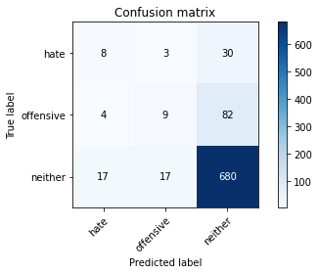

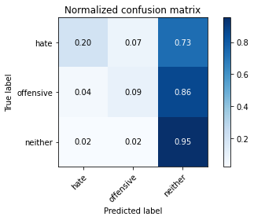

precision recall f1-score support

hate 0.28 0.20 0.23 41

offensive 0.31 0.09 0.15 95

neither 0.86 0.95 0.90 714

accuracy 0.82 850

macro avg 0.48 0.41 0.43 850

weighted avg 0.77 0.82 0.79 850

average eval_loss: 0.488132816826015, accuracy: 0.82

training 5 epoch...

10.702138423919678 seconds used......

5 training finished! average train loss: 0.20136015804914328

evaluating...

Confusion matrix, without normalization

[[ 8 11 22]

[ 5 27 63]

[ 23 70 621]]

Normalized confusion matrix

[[0.19512195 0.26829268 0.53658537]

[0.05263158 0.28421053 0.66315789]

[0.03221289 0.09803922 0.8697479 ]]

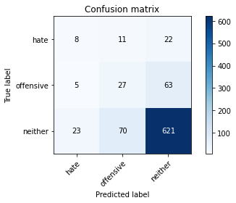

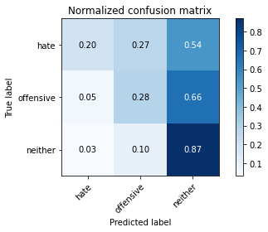

precision recall f1-score support

hate 0.22 0.20 0.21 41

offensive 0.25 0.28 0.27 95

neither 0.88 0.87 0.87 714

accuracy 0.77 850

macro avg 0.45 0.45 0.45 850

weighted avg 0.78 0.77 0.77 850

average eval_loss: 0.6367203601592675, accuracy: 0.7717647058823529

training 6 epoch...

10.543163299560547 seconds used......

6 training finished! average train loss: 0.12087223827838897

evaluating...

Confusion matrix, without normalization

[[ 5 8 28]

[ 0 24 71]

[ 12 45 657]]

Normalized confusion matrix

[[0.12195122 0.19512195 0.68292683]

[0. 0.25263158 0.74736842]

[0.01680672 0.06302521 0.92016807]]

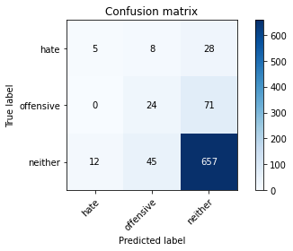

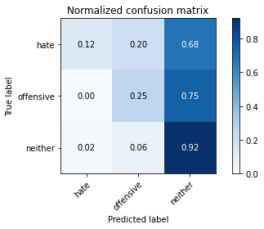

precision recall f1-score support

hate 0.29 0.12 0.17 41

offensive 0.31 0.25 0.28 95

neither 0.87 0.92 0.89 714

accuracy 0.81 850

macro avg 0.49 0.43 0.45 850

weighted avg 0.78 0.81 0.79 850

average eval_loss: 0.7082314754912067, accuracy: 0.8070588235294117

training 7 epoch...

10.62928819656372 seconds used......

7 training finished! average train loss: 0.057284036694237817

evaluating...

Confusion matrix, without normalization

[[ 4 15 22]

[ 3 40 52]

[ 14 90 610]]

Normalized confusion matrix

[[0.09756098 0.36585366 0.53658537]

[0.03157895 0.42105263 0.54736842]

[0.01960784 0.12605042 0.85434174]]

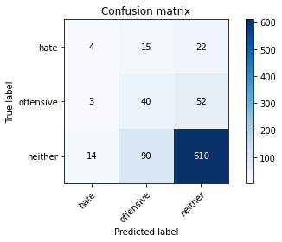

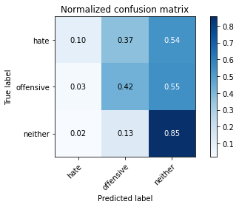

precision recall f1-score support

hate 0.19 0.10 0.13 41

offensive 0.28 0.42 0.33 95

neither 0.89 0.85 0.87 714

accuracy 0.77 850

macro avg 0.45 0.46 0.45 850

weighted avg 0.79 0.77 0.78 850

average eval_loss: 0.8587654068318824, accuracy: 0.7694117647058824

training 8 epoch...

10.56722617149353 seconds used......

8 training finished! average train loss: 0.019848053332848045

evaluating...

Confusion matrix, without normalization

[[ 2 10 29]

[ 1 20 74]

[ 7 35 672]]

Normalized confusion matrix

[[0.04878049 0.24390244 0.70731707]

[0.01052632 0.21052632 0.77894737]

[0.00980392 0.04901961 0.94117647]]

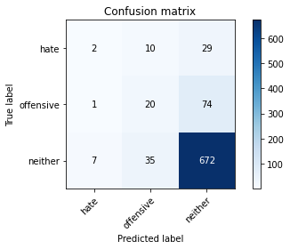

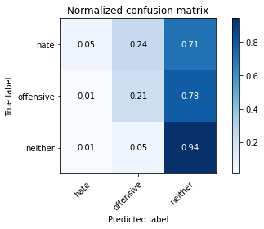

precision recall f1-score support

hate 0.20 0.05 0.08 41

offensive 0.31 0.21 0.25 95

neither 0.87 0.94 0.90 714

accuracy 0.82 850

macro avg 0.46 0.40 0.41 850

weighted avg 0.77 0.82 0.79 850

average eval_loss: 0.9222289395016391, accuracy: 0.8164705882352942

training 9 epoch...

10.541473865509033 seconds used......

9 training finished! average train loss: 0.015982219541015533

evaluating...

Confusion matrix, without normalization

[[ 2 23 16]

[ 2 43 50]

[ 7 138 569]]

Normalized confusion matrix

[[0.04878049 0.56097561 0.3902439 ]

[0.02105263 0.45263158 0.52631579]

[0.00980392 0.19327731 0.79691877]]

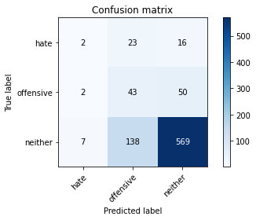

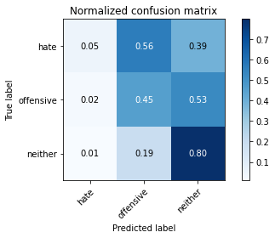

precision recall f1-score support

hate 0.18 0.05 0.08 41

offensive 0.21 0.45 0.29 95

neither 0.90 0.80 0.84 714

accuracy 0.72 850

macro avg 0.43 0.43 0.40 850

weighted avg 0.79 0.72 0.74 850

average eval_loss: 1.1616199681410826, accuracy: 0.7223529411764706

training 10 epoch...

10.575258255004883 seconds used......

10 training finished! average train loss: 0.007374542523533679

evaluating...

Confusion matrix, without normalization

[[ 2 19 20]

[ 1 44 50]

[ 10 116 588]]

Normalized confusion matrix

[[0.04878049 0.46341463 0.48780488]

[0.01052632 0.46315789 0.52631579]

[0.0140056 0.16246499 0.82352941]]

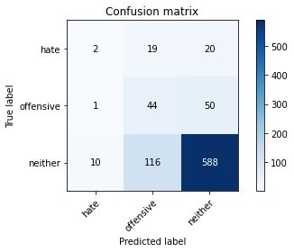

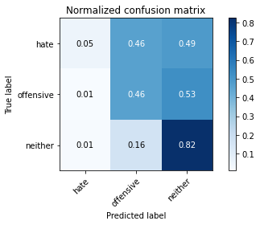

precision recall f1-score support

hate 0.15 0.05 0.07 41

offensive 0.25 0.46 0.32 95

neither 0.89 0.82 0.86 714

accuracy 0.75 850

macro avg 0.43 0.45 0.42 850

weighted avg 0.79 0.75 0.76 850

average eval_loss: 1.096350983389637, accuracy: 0.7458823529411764

training 11 epoch...

10.570754051208496 seconds used......

11 training finished! average train loss: 0.00619614940459052

evaluating...

Confusion matrix, without normalization

[[ 1 19 21]

[ 1 39 55]

[ 5 121 588]]

Normalized confusion matrix

[[0.02439024 0.46341463 0.51219512]

[0.01052632 0.41052632 0.57894737]

[0.0070028 0.16946779 0.82352941]]

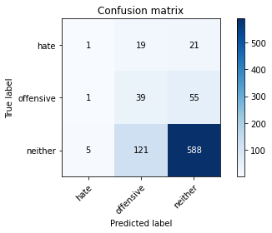

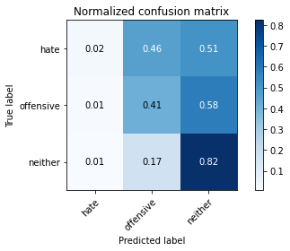

precision recall f1-score support

hate 0.14 0.02 0.04 41

offensive 0.22 0.41 0.28 95

neither 0.89 0.82 0.85 714

accuracy 0.74 850

macro avg 0.42 0.42 0.39 850

weighted avg 0.78 0.74 0.75 850

average eval_loss: 1.1811479415536754, accuracy: 0.7388235294117647

training 12 epoch...

10.686411380767822 seconds used......

12 training finished! average train loss: 0.0032451963670050293

evaluating...

Confusion matrix, without normalization

[[ 4 13 24]

[ 2 37 56]

[ 15 89 610]]

Normalized confusion matrix

[[0.09756098 0.31707317 0.58536585]

[0.02105263 0.38947368 0.58947368]

[0.0210084 0.12464986 0.85434174]]

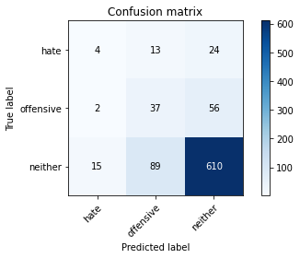

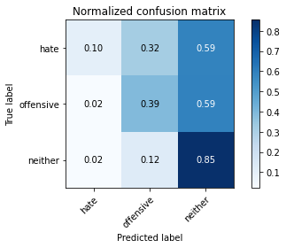

precision recall f1-score support

hate 0.19 0.10 0.13 41

offensive 0.27 0.39 0.32 95

neither 0.88 0.85 0.87 714

accuracy 0.77 850

macro avg 0.45 0.45 0.44 850

weighted avg 0.78 0.77 0.77 850

average eval_loss: 1.1397469097888504, accuracy: 0.7658823529411765

training 13 epoch...

10.583242893218994 seconds used......

13 training finished! average train loss: 0.004908130156735961

evaluating...

Confusion matrix, without normalization

[[ 1 14 26]

[ 1 34 60]

[ 7 82 625]]

Normalized confusion matrix

[[0.02439024 0.34146341 0.63414634]

[0.01052632 0.35789474 0.63157895]

[0.00980392 0.11484594 0.87535014]]

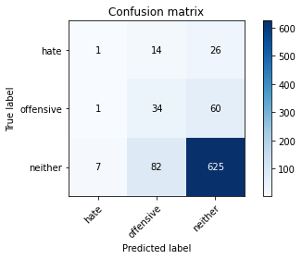

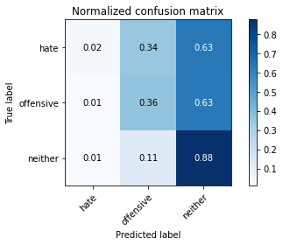

precision recall f1-score support

hate 0.11 0.02 0.04 41

offensive 0.26 0.36 0.30 95

neither 0.88 0.88 0.88 714

accuracy 0.78 850

macro avg 0.42 0.42 0.41 850

weighted avg 0.77 0.78 0.77 850

average eval_loss: 1.1629062051655383, accuracy: 0.7764705882352941

training 14 epoch...

10.652820587158203 seconds used......

14 training finished! average train loss: 0.0026003124286384824

evaluating...

Confusion matrix, without normalization

[[ 3 24 14]

[ 1 68 26]

[ 10 176 528]]

Normalized confusion matrix

[[0.07317073 0.58536585 0.34146341]

[0.01052632 0.71578947 0.27368421]

[0.0140056 0.2464986 0.7394958 ]]

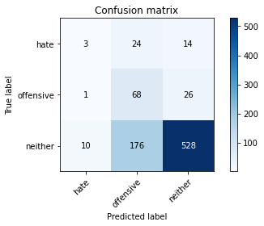

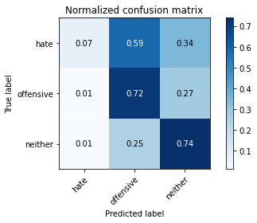

precision recall f1-score support

hate 0.21 0.07 0.11 41

offensive 0.25 0.72 0.37 95

neither 0.93 0.74 0.82 714

accuracy 0.70 850

macro avg 0.47 0.51 0.44 850

weighted avg 0.82 0.70 0.74 850

average eval_loss: 1.55168660714844, accuracy: 0.7047058823529412

training 15 epoch...

10.572681903839111 seconds used......

15 training finished! average train loss: 0.0021520778550229106

evaluating...

Confusion matrix, without normalization

[[ 1 15 25]

[ 1 33 61]

[ 8 69 637]]

Normalized confusion matrix

[[0.02439024 0.36585366 0.6097561 ]

[0.01052632 0.34736842 0.64210526]

[0.01120448 0.09663866 0.89215686]]

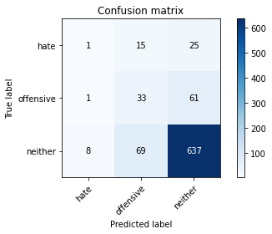

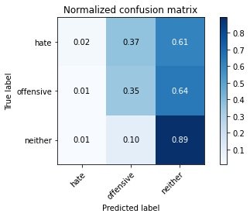

precision recall f1-score support

hate 0.10 0.02 0.04 41

offensive 0.28 0.35 0.31 95

neither 0.88 0.89 0.89 714

accuracy 0.79 850

macro avg 0.42 0.42 0.41 850

weighted avg 0.78 0.79 0.78 850

average eval_loss: 1.174176958371898, accuracy: 0.7894117647058824

training 16 epoch...

10.674534320831299 seconds used......

16 training finished! average train loss: 0.0010945264491825722

evaluating...

Confusion matrix, without normalization

[[ 3 17 21]

[ 3 43 49]

[ 12 105 597]]

Normalized confusion matrix

[[0.07317073 0.41463415 0.51219512]

[0.03157895 0.45263158 0.51578947]

[0.01680672 0.14705882 0.83613445]]

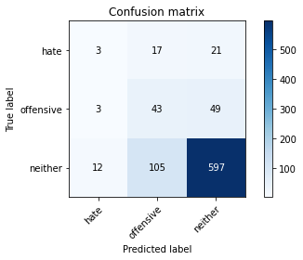

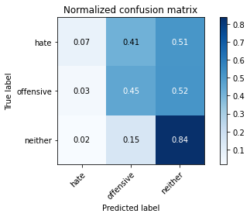

precision recall f1-score support

hate 0.17 0.07 0.10 41

offensive 0.26 0.45 0.33 95

neither 0.90 0.84 0.86 714

accuracy 0.76 850

macro avg 0.44 0.45 0.43 850

weighted avg 0.79 0.76 0.77 850

average eval_loss: 1.2499908234435573, accuracy: 0.7564705882352941

training 17 epoch...

10.55037546157837 seconds used......

17 training finished! average train loss: 0.0010099719902007984

evaluating...

Confusion matrix, without normalization

[[ 1 15 25]

[ 1 39 55]

[ 7 96 611]]

Normalized confusion matrix

[[0.02439024 0.36585366 0.6097561 ]

[0.01052632 0.41052632 0.57894737]

[0.00980392 0.13445378 0.8557423 ]]

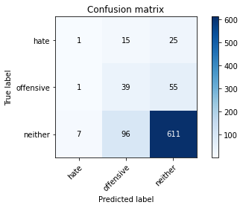

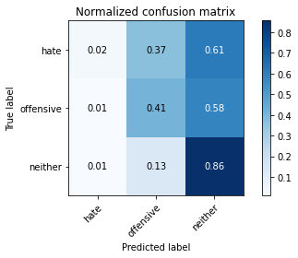

precision recall f1-score support

hate 0.11 0.02 0.04 41

offensive 0.26 0.41 0.32 95

neither 0.88 0.86 0.87 714

accuracy 0.77 850

macro avg 0.42 0.43 0.41 850

weighted avg 0.78 0.77 0.77 850

average eval_loss: 1.273413670327119, accuracy: 0.7658823529411765

training 18 epoch...

10.555800199508667 seconds used......

18 training finished! average train loss: 0.0006306616446146599

evaluating...

Confusion matrix, without normalization

[[ 1 15 25]

[ 1 38 56]

[ 9 93 612]]

Normalized confusion matrix

[[0.02439024 0.36585366 0.6097561 ]

[0.01052632 0.4 0.58947368]

[0.01260504 0.1302521 0.85714286]]

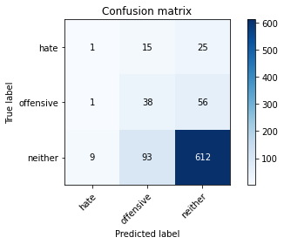

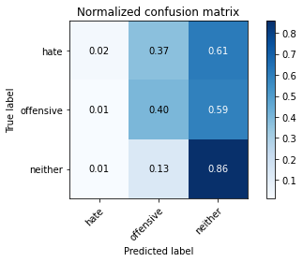

precision recall f1-score support

hate 0.09 0.02 0.04 41

offensive 0.26 0.40 0.32 95

neither 0.88 0.86 0.87 714

accuracy 0.77 850

macro avg 0.41 0.43 0.41 850

weighted avg 0.78 0.77 0.77 850

average eval_loss: 1.2842935289415838, accuracy: 0.7658823529411765

training 19 epoch...

10.636958122253418 seconds used......

19 training finished! average train loss: 0.00043398501662662826

evaluating...

Confusion matrix, without normalization

[[ 2 14 25]

[ 1 39 55]

[ 9 99 606]]

Normalized confusion matrix

[[0.04878049 0.34146341 0.6097561 ]

[0.01052632 0.41052632 0.57894737]

[0.01260504 0.13865546 0.8487395 ]]

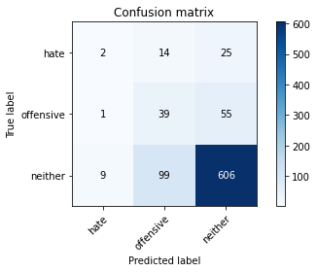

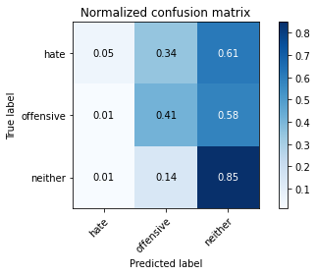

precision recall f1-score support

hate 0.17 0.05 0.08 41

offensive 0.26 0.41 0.32 95

neither 0.88 0.85 0.87 714

accuracy 0.76 850

macro avg 0.44 0.44 0.42 850

weighted avg 0.78 0.76 0.77 850

average eval_loss: 1.316130546663856, accuracy: 0.7611764705882353

training 20 epoch...

10.545821189880371 seconds used......

20 training finished! average train loss: 0.0016214634589582252

evaluating...

Confusion matrix, without normalization

[[ 7 23 11]

[ 5 76 14]

[ 28 222 464]]

Normalized confusion matrix

[[0.17073171 0.56097561 0.26829268]

[0.05263158 0.8 0.14736842]

[0.03921569 0.31092437 0.64985994]]

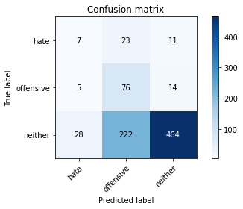

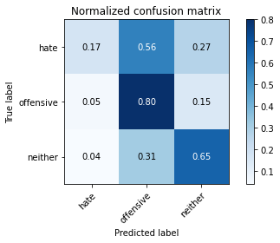

precision recall f1-score support

hate 0.17 0.17 0.17 41

offensive 0.24 0.80 0.37 95

neither 0.95 0.65 0.77 714

accuracy 0.64 850

macro avg 0.45 0.54 0.44 850

weighted avg 0.83 0.64 0.70 850

average eval_loss: 2.2422237438975485, accuracy: 0.6435294117647059

3 run......

training 1 epoch...

10.666419267654419 seconds used......

1 training finished! average train loss: 0.7595500629681807

evaluating...

Confusion matrix, without normalization

[[ 0 0 41]

[ 0 0 95]

[ 0 0 714]]

Normalized confusion matrix

[[0. 0. 1.]

[0. 0. 1.]

[0. 0. 1.]]





/opt/conda/lib/python3.7/site-packages/sklearn/metrics/_classification.py:1245: UndefinedMetricWarning: Precision and F-score are ill-defined and being set to 0.0 in labels with no predicted samples. Use `zero_division` parameter to control this behavior.

_warn_prf(average, modifier, msg_start, len(result))

/opt/conda/lib/python3.7/site-packages/sklearn/metrics/_classification.py:1245: UndefinedMetricWarning: Precision and F-score are ill-defined and being set to 0.0 in labels with no predicted samples. Use `zero_division` parameter to control this behavior.

_warn_prf(average, modifier, msg_start, len(result))

/opt/conda/lib/python3.7/site-packages/sklearn/metrics/_classification.py:1245: UndefinedMetricWarning: Precision and F-score are ill-defined and being set to 0.0 in labels with no predicted samples. Use `zero_division` parameter to control this behavior.

_warn_prf(average, modifier, msg_start, len(result))

precision recall f1-score support

hate 0.00 0.00 0.00 41

offensive 0.00 0.00 0.00 95

neither 0.84 1.00 0.91 714

accuracy 0.84 850

macro avg 0.28 0.33 0.30 850

weighted avg 0.71 0.84 0.77 850

average eval_loss: 0.5899853345959686, accuracy: 0.84

training 2 epoch...

10.55003046989441 seconds used......

2 training finished! average train loss: 0.6557585968421056

evaluating...

Confusion matrix, without normalization

[[ 0 0 41]

[ 0 1 94]

[ 1 4 709]]

Normalized confusion matrix

[[0. 0. 1. ]

[0. 0.01052632 0.98947368]

[0.00140056 0.00560224 0.9929972 ]]

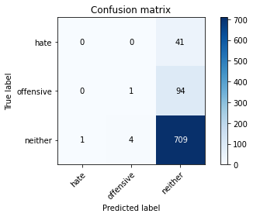

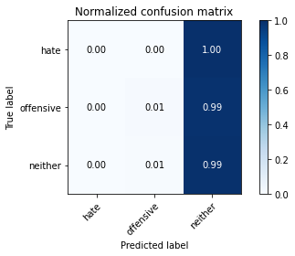

precision recall f1-score support

hate 0.00 0.00 0.00 41

offensive 0.20 0.01 0.02 95

neither 0.84 0.99 0.91 714

accuracy 0.84 850

macro avg 0.35 0.33 0.31 850

weighted avg 0.73 0.84 0.77 850

average eval_loss: 0.4919709344935972, accuracy: 0.8352941176470589

training 3 epoch...

10.637598991394043 seconds used......

3 training finished! average train loss: 0.5054141752994977

evaluating...

Confusion matrix, without normalization

[[ 5 0 36]

[ 3 1 91]

[ 10 1 703]]

Normalized confusion matrix

[[0.12195122 0. 0.87804878]

[0.03157895 0.01052632 0.95789474]

[0.0140056 0.00140056 0.98459384]]

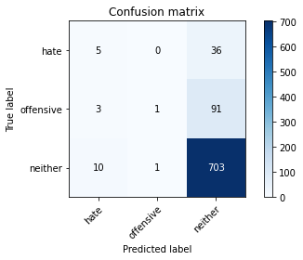

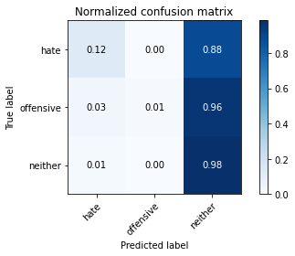

precision recall f1-score support

hate 0.28 0.12 0.17 41

offensive 0.50 0.01 0.02 95

neither 0.85 0.98 0.91 714

accuracy 0.83 850

macro avg 0.54 0.37 0.37 850

weighted avg 0.78 0.83 0.78 850

average eval_loss: 0.4961119011520993, accuracy: 0.8341176470588235

training 4 epoch...

10.580490589141846 seconds used......

4 training finished! average train loss: 0.32574845426357707

evaluating...

Confusion matrix, without normalization

[[ 6 8 27]

[ 7 35 53]

[ 31 45 638]]

Normalized confusion matrix

[[0.14634146 0.19512195 0.65853659]

[0.07368421 0.36842105 0.55789474]

[0.04341737 0.06302521 0.89355742]]

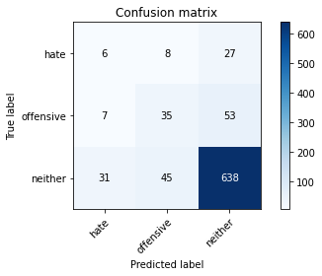

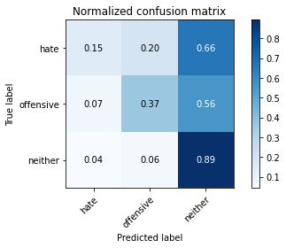

precision recall f1-score support

hate 0.14 0.15 0.14 41

offensive 0.40 0.37 0.38 95

neither 0.89 0.89 0.89 714

accuracy 0.80 850

macro avg 0.47 0.47 0.47 850

weighted avg 0.80 0.80 0.80 850

average eval_loss: 0.5066053504774044, accuracy: 0.7988235294117647

training 5 epoch...

10.5919029712677 seconds used......

5 training finished! average train loss: 0.16133108385480366

evaluating...

Confusion matrix, without normalization

[[ 5 12 24]

[ 6 22 67]

[ 23 66 625]]

Normalized confusion matrix

[[0.12195122 0.29268293 0.58536585]

[0.06315789 0.23157895 0.70526316]

[0.03221289 0.09243697 0.87535014]]

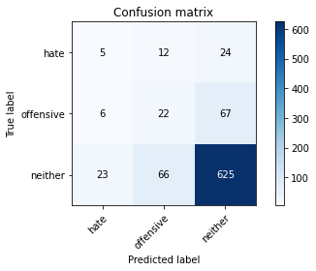

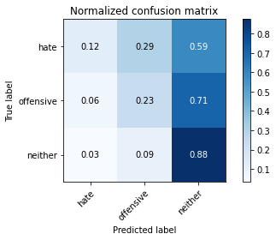

precision recall f1-score support

hate 0.15 0.12 0.13 41

offensive 0.22 0.23 0.23 95

neither 0.87 0.88 0.87 714

accuracy 0.77 850

macro avg 0.41 0.41 0.41 850

weighted avg 0.76 0.77 0.77 850

average eval_loss: 0.6559765180139694, accuracy: 0.7670588235294118

training 6 epoch...

10.544755697250366 seconds used......

6 training finished! average train loss: 0.06270065111323045

evaluating...

Confusion matrix, without normalization

[[ 6 11 24]

[ 7 28 60]

[ 27 66 621]]

Normalized confusion matrix

[[0.14634146 0.26829268 0.58536585]

[0.07368421 0.29473684 0.63157895]

[0.03781513 0.09243697 0.8697479 ]]

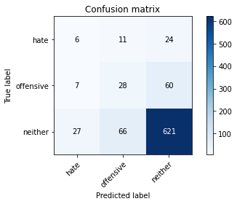

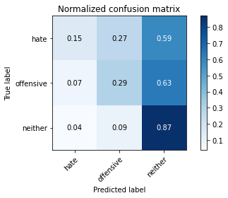

precision recall f1-score support

hate 0.15 0.15 0.15 41

offensive 0.27 0.29 0.28 95

neither 0.88 0.87 0.88 714

accuracy 0.77 850

macro avg 0.43 0.44 0.43 850

weighted avg 0.78 0.77 0.77 850

average eval_loss: 0.7536538143663906, accuracy: 0.7705882352941177

training 7 epoch...

10.558249473571777 seconds used......

7 training finished! average train loss: 0.023080217118303364

evaluating...

Confusion matrix, without normalization

[[ 5 11 25]

[ 3 38 54]

[ 13 84 617]]

Normalized confusion matrix

[[0.12195122 0.26829268 0.6097561 ]

[0.03157895 0.4 0.56842105]

[0.01820728 0.11764706 0.86414566]]

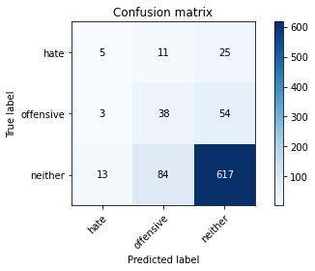

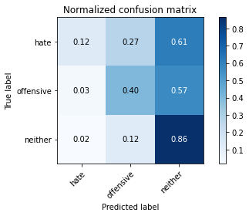

precision recall f1-score support

hate 0.24 0.12 0.16 41

offensive 0.29 0.40 0.33 95

neither 0.89 0.86 0.88 714

accuracy 0.78 850

macro avg 0.47 0.46 0.46 850

weighted avg 0.79 0.78 0.78 850

average eval_loss: 0.8493121955110583, accuracy: 0.7764705882352941

training 8 epoch...

10.596491813659668 seconds used......

8 training finished! average train loss: 0.014105592757606736

evaluating...

Confusion matrix, without normalization

[[ 5 19 17]

[ 3 58 34]

[ 16 133 565]]

Normalized confusion matrix

[[0.12195122 0.46341463 0.41463415]

[0.03157895 0.61052632 0.35789474]

[0.02240896 0.18627451 0.79131653]]

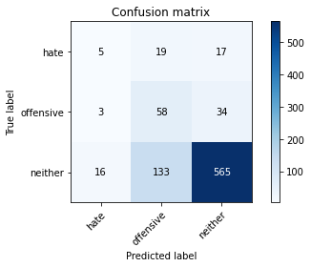

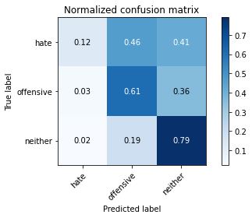

precision recall f1-score support

hate 0.21 0.12 0.15 41

offensive 0.28 0.61 0.38 95

neither 0.92 0.79 0.85 714

accuracy 0.74 850

macro avg 0.47 0.51 0.46 850

weighted avg 0.81 0.74 0.76 850

average eval_loss: 1.0672826659567871, accuracy: 0.7388235294117647

training 9 epoch...

10.537230491638184 seconds used......

9 training finished! average train loss: 0.008157267521780271

evaluating...

Confusion matrix, without normalization

[[ 4 8 29]

[ 2 19 74]

[ 15 58 641]]

Normalized confusion matrix

[[0.09756098 0.19512195 0.70731707]

[0.02105263 0.2 0.77894737]

[0.0210084 0.08123249 0.8977591 ]]

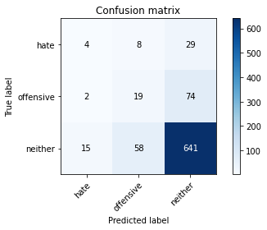

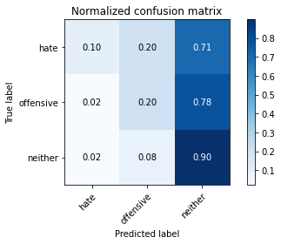

precision recall f1-score support

hate 0.19 0.10 0.13 41

offensive 0.22 0.20 0.21 95

neither 0.86 0.90 0.88 714

accuracy 0.78 850

macro avg 0.43 0.40 0.41 850

weighted avg 0.76 0.78 0.77 850

average eval_loss: 0.9948009712070628, accuracy: 0.7811764705882352

training 10 epoch...

10.601548910140991 seconds used......

10 training finished! average train loss: 0.007549674733756826

evaluating...

Confusion matrix, without normalization

[[ 1 7 33]

[ 2 11 82]

[ 10 38 666]]

Normalized confusion matrix

[[0.02439024 0.17073171 0.80487805]

[0.02105263 0.11578947 0.86315789]

[0.0140056 0.05322129 0.93277311]]

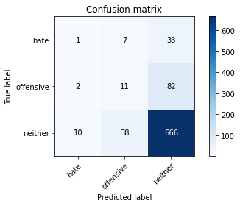

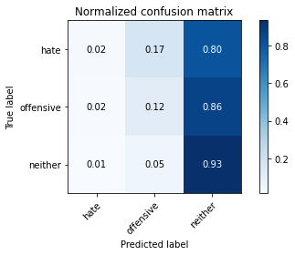

precision recall f1-score support

hate 0.08 0.02 0.04 41

offensive 0.20 0.12 0.15 95

neither 0.85 0.93 0.89 714

accuracy 0.80 850

macro avg 0.38 0.36 0.36 850

weighted avg 0.74 0.80 0.77 850

average eval_loss: 1.0384427082266654, accuracy: 0.7976470588235294

training 11 epoch...

10.543492078781128 seconds used......

11 training finished! average train loss: 0.008860770496539772

evaluating...

Confusion matrix, without normalization

[[ 4 8 29]

[ 2 17 76]

[ 15 52 647]]

Normalized confusion matrix

[[0.09756098 0.19512195 0.70731707]

[0.02105263 0.17894737 0.8 ]

[0.0210084 0.07282913 0.90616246]]

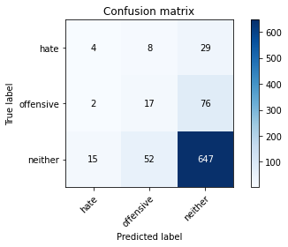

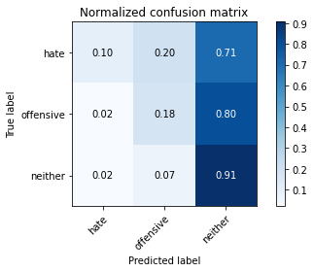

precision recall f1-score support

hate 0.19 0.10 0.13 41

offensive 0.22 0.18 0.20 95

neither 0.86 0.91 0.88 714

accuracy 0.79 850

macro avg 0.42 0.39 0.40 850

weighted avg 0.76 0.79 0.77 850

average eval_loss: 1.0533618089072216, accuracy: 0.7858823529411765

training 12 epoch...

10.595985174179077 seconds used......

12 training finished! average train loss: 0.010640706627880438

evaluating...

Confusion matrix, without normalization

[[ 4 10 27]

[ 3 23 69]

[ 17 67 630]]

Normalized confusion matrix

[[0.09756098 0.24390244 0.65853659]

[0.03157895 0.24210526 0.72631579]

[0.02380952 0.09383754 0.88235294]]

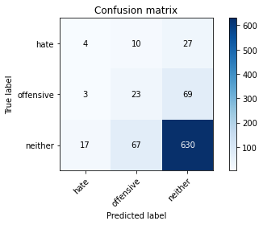

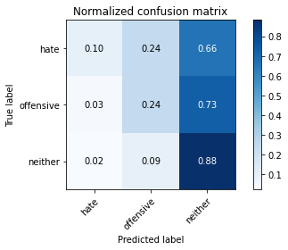

precision recall f1-score support

hate 0.17 0.10 0.12 41

offensive 0.23 0.24 0.24 95

neither 0.87 0.88 0.87 714

accuracy 0.77 850

macro avg 0.42 0.41 0.41 850

weighted avg 0.76 0.77 0.77 850

average eval_loss: 1.0624807853221916, accuracy: 0.7729411764705882

training 13 epoch...

10.54730749130249 seconds used......

13 training finished! average train loss: 0.006781932603693209

evaluating...

Confusion matrix, without normalization

[[ 4 12 25]

[ 3 21 71]

[ 18 68 628]]

Normalized confusion matrix

[[0.09756098 0.29268293 0.6097561 ]

[0.03157895 0.22105263 0.74736842]

[0.02521008 0.0952381 0.87955182]]

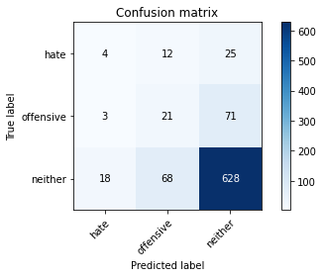

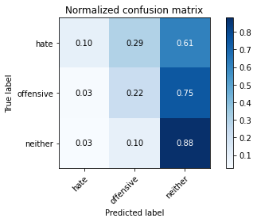

precision recall f1-score support

hate 0.16 0.10 0.12 41

offensive 0.21 0.22 0.21 95

neither 0.87 0.88 0.87 714

accuracy 0.77 850

macro avg 0.41 0.40 0.40 850

weighted avg 0.76 0.77 0.76 850

average eval_loss: 1.1470855547204548, accuracy: 0.768235294117647

training 14 epoch...

10.582086563110352 seconds used......

14 training finished! average train loss: 0.009001572210287962

evaluating...

Confusion matrix, without normalization

[[ 3 7 31]

[ 2 17 76]

[ 16 43 655]]

Normalized confusion matrix

[[0.07317073 0.17073171 0.75609756]

[0.02105263 0.17894737 0.8 ]

[0.02240896 0.06022409 0.91736695]]

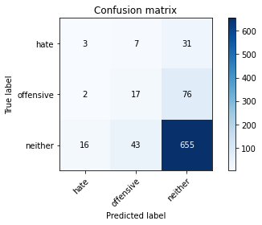

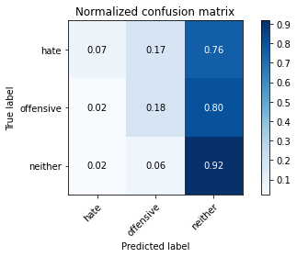

precision recall f1-score support

hate 0.14 0.07 0.10 41

offensive 0.25 0.18 0.21 95

neither 0.86 0.92 0.89 714

accuracy 0.79 850

macro avg 0.42 0.39 0.40 850

weighted avg 0.76 0.79 0.77 850

average eval_loss: 1.0083114101458748, accuracy: 0.7941176470588235

training 15 epoch...

10.548990964889526 seconds used......

15 training finished! average train loss: 0.0023042849318769118

evaluating...

Confusion matrix, without normalization

[[ 4 10 27]

[ 2 27 66]

[ 16 73 625]]

Normalized confusion matrix

[[0.09756098 0.24390244 0.65853659]

[0.02105263 0.28421053 0.69473684]

[0.02240896 0.1022409 0.87535014]]

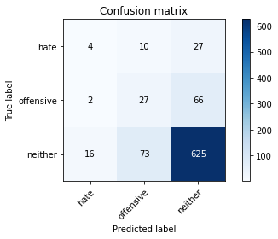

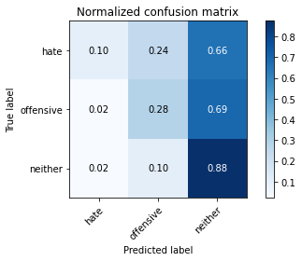

precision recall f1-score support

hate 0.18 0.10 0.13 41

offensive 0.25 0.28 0.26 95

neither 0.87 0.88 0.87 714

accuracy 0.77 850

macro avg 0.43 0.42 0.42 850

weighted avg 0.77 0.77 0.77 850

average eval_loss: 1.0841605609870342, accuracy: 0.7717647058823529

training 16 epoch...

10.543158054351807 seconds used......

16 training finished! average train loss: 0.0015395146122990319

evaluating...

Confusion matrix, without normalization

[[ 4 15 22]

[ 2 35 58]

[ 13 98 603]]

Normalized confusion matrix

[[0.09756098 0.36585366 0.53658537]

[0.02105263 0.36842105 0.61052632]

[0.01820728 0.1372549 0.84453782]]

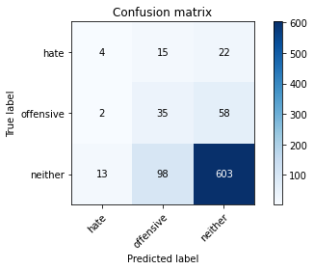

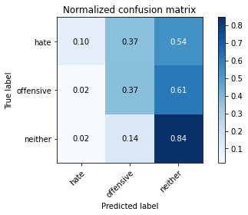

precision recall f1-score support

hate 0.21 0.10 0.13 41

offensive 0.24 0.37 0.29 95

neither 0.88 0.84 0.86 714

accuracy 0.76 850

macro avg 0.44 0.44 0.43 850

weighted avg 0.78 0.76 0.76 850

average eval_loss: 1.1792932121992805, accuracy: 0.7552941176470588

training 17 epoch...

10.6003098487854 seconds used......

17 training finished! average train loss: 0.0013594149466371163

evaluating...

Confusion matrix, without normalization

[[ 4 13 24]

[ 5 25 65]

[ 16 84 614]]

Normalized confusion matrix

[[0.09756098 0.31707317 0.58536585]

[0.05263158 0.26315789 0.68421053]

[0.02240896 0.11764706 0.85994398]]

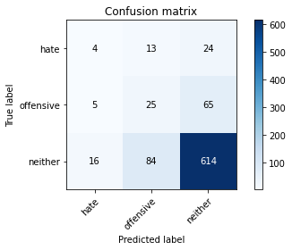

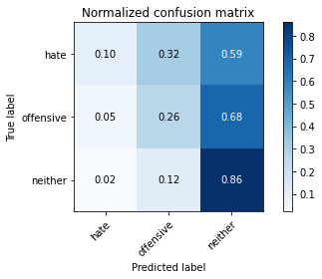

precision recall f1-score support

hate 0.16 0.10 0.12 41

offensive 0.20 0.26 0.23 95

neither 0.87 0.86 0.87 714

accuracy 0.76 850

macro avg 0.41 0.41 0.41 850

weighted avg 0.76 0.76 0.76 850

average eval_loss: 1.2082826615728135, accuracy: 0.7564705882352941

training 18 epoch...

10.556398630142212 seconds used......

18 training finished! average train loss: 0.0007321185452523283

evaluating...

Confusion matrix, without normalization

[[ 4 12 25]

[ 3 26 66]

[ 15 80 619]]

Normalized confusion matrix

[[0.09756098 0.29268293 0.6097561 ]

[0.03157895 0.27368421 0.69473684]

[0.0210084 0.11204482 0.86694678]]

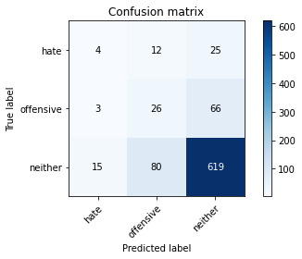

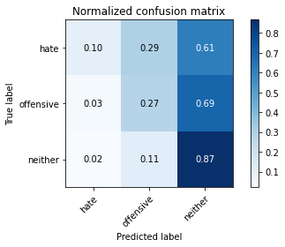

precision recall f1-score support

hate 0.18 0.10 0.13 41

offensive 0.22 0.27 0.24 95

neither 0.87 0.87 0.87 714

accuracy 0.76 850

macro avg 0.42 0.41 0.41 850

weighted avg 0.77 0.76 0.76 850

average eval_loss: 1.2032532720409637, accuracy: 0.7635294117647059

training 19 epoch...

10.599270582199097 seconds used......

19 training finished! average train loss: 0.0005969450242656212

evaluating...

Confusion matrix, without normalization

[[ 4 12 25]

[ 3 23 69]

[ 15 73 626]]

Normalized confusion matrix

[[0.09756098 0.29268293 0.6097561 ]

[0.03157895 0.24210526 0.72631579]

[0.0210084 0.1022409 0.8767507 ]]

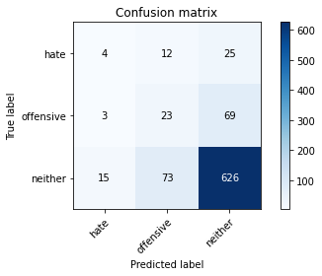

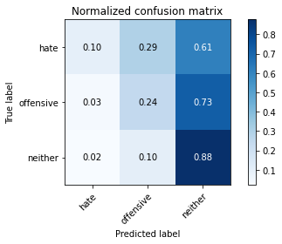

precision recall f1-score support

hate 0.18 0.10 0.13 41

offensive 0.21 0.24 0.23 95

neither 0.87 0.88 0.87 714

accuracy 0.77 850

macro avg 0.42 0.41 0.41 850

weighted avg 0.76 0.77 0.76 850

average eval_loss: 1.2029780852473015, accuracy: 0.768235294117647

training 20 epoch...

10.551849126815796 seconds used......

20 training finished! average train loss: 0.0008083494406981537

evaluating...

Confusion matrix, without normalization

[[ 4 13 24]

[ 4 27 64]

[ 16 93 605]]

Normalized confusion matrix

[[0.09756098 0.31707317 0.58536585]

[0.04210526 0.28421053 0.67368421]

[0.02240896 0.1302521 0.84733894]]

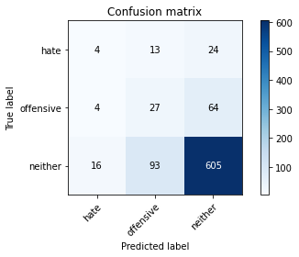

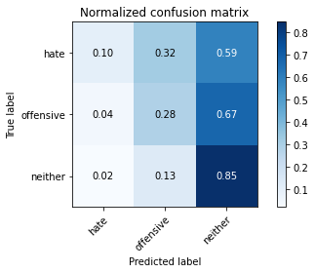

precision recall f1-score support

hate 0.17 0.10 0.12 41

offensive 0.20 0.28 0.24 95

neither 0.87 0.85 0.86 714

accuracy 0.75 850

macro avg 0.41 0.41 0.41 850

weighted avg 0.76 0.75 0.75 850

average eval_loss: 1.340545673196767, accuracy: 0.7482352941176471

4 run......

training 1 epoch...

10.61486554145813 seconds used......

1 training finished! average train loss: 0.7436805124466236

evaluating...

Confusion matrix, without normalization

[[ 0 0 41]

[ 0 0 95]

[ 0 0 714]]

Normalized confusion matrix

[[0. 0. 1.]

[0. 0. 1.]

[0. 0. 1.]]





/opt/conda/lib/python3.7/site-packages/sklearn/metrics/_classification.py:1245: UndefinedMetricWarning: Precision and F-score are ill-defined and being set to 0.0 in labels with no predicted samples. Use `zero_division` parameter to control this behavior.

_warn_prf(average, modifier, msg_start, len(result))

/opt/conda/lib/python3.7/site-packages/sklearn/metrics/_classification.py:1245: UndefinedMetricWarning: Precision and F-score are ill-defined and being set to 0.0 in labels with no predicted samples. Use `zero_division` parameter to control this behavior.

_warn_prf(average, modifier, msg_start, len(result))

/opt/conda/lib/python3.7/site-packages/sklearn/metrics/_classification.py:1245: UndefinedMetricWarning: Precision and F-score are ill-defined and being set to 0.0 in labels with no predicted samples. Use `zero_division` parameter to control this behavior.

_warn_prf(average, modifier, msg_start, len(result))

precision recall f1-score support

hate 0.00 0.00 0.00 41

offensive 0.00 0.00 0.00 95

neither 0.84 1.00 0.91 714

accuracy 0.84 850

macro avg 0.28 0.33 0.30 850

weighted avg 0.71 0.84 0.77 850

average eval_loss: 0.557999380799227, accuracy: 0.84

training 2 epoch...

10.541033267974854 seconds used......

2 training finished! average train loss: 0.6513741176861984

evaluating...

Confusion matrix, without normalization

[[ 4 0 37]

[ 2 0 93]

[ 9 0 705]]

Normalized confusion matrix

[[0.09756098 0. 0.90243902]

[0.02105263 0. 0.97894737]

[0.01260504 0. 0.98739496]]

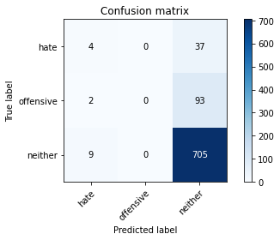

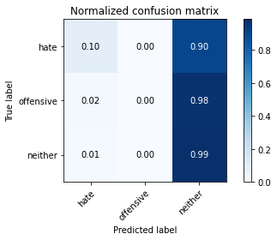

/opt/conda/lib/python3.7/site-packages/sklearn/metrics/_classification.py:1245: UndefinedMetricWarning: Precision and F-score are ill-defined and being set to 0.0 in labels with no predicted samples. Use `zero_division` parameter to control this behavior.

_warn_prf(average, modifier, msg_start, len(result))

/opt/conda/lib/python3.7/site-packages/sklearn/metrics/_classification.py:1245: UndefinedMetricWarning: Precision and F-score are ill-defined and being set to 0.0 in labels with no predicted samples. Use `zero_division` parameter to control this behavior.

_warn_prf(average, modifier, msg_start, len(result))

/opt/conda/lib/python3.7/site-packages/sklearn/metrics/_classification.py:1245: UndefinedMetricWarning: Precision and F-score are ill-defined and being set to 0.0 in labels with no predicted samples. Use `zero_division` parameter to control this behavior.

_warn_prf(average, modifier, msg_start, len(result))

precision recall f1-score support

hate 0.27 0.10 0.14 41

offensive 0.00 0.00 0.00 95

neither 0.84 0.99 0.91 714

accuracy 0.83 850

macro avg 0.37 0.36 0.35 850

weighted avg 0.72 0.83 0.77 850

average eval_loss: 0.47828641481870826, accuracy: 0.8341176470588235

training 3 epoch...

10.587473154067993 seconds used......

3 training finished! average train loss: 0.49834894515000855

evaluating...

Confusion matrix, without normalization

[[ 7 1 33]

[ 7 2 86]

[ 19 1 694]]

Normalized confusion matrix

[[0.17073171 0.02439024 0.80487805]

[0.07368421 0.02105263 0.90526316]

[0.02661064 0.00140056 0.9719888 ]]

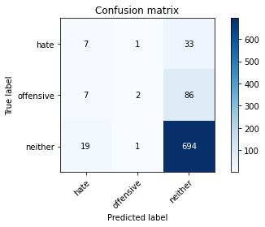

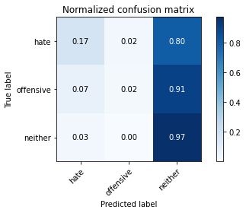

precision recall f1-score support

hate 0.21 0.17 0.19 41

offensive 0.50 0.02 0.04 95

neither 0.85 0.97 0.91 714

accuracy 0.83 850

macro avg 0.52 0.39 0.38 850

weighted avg 0.78 0.83 0.78 850

average eval_loss: 0.4645496006015428, accuracy: 0.8270588235294117

training 4 epoch...

10.529213905334473 seconds used......

4 training finished! average train loss: 0.3213587298989296

evaluating...

Confusion matrix, without normalization

[[ 11 1 29]

[ 11 11 73]

[ 26 6 682]]

Normalized confusion matrix

[[0.26829268 0.02439024 0.70731707]

[0.11578947 0.11578947 0.76842105]

[0.03641457 0.00840336 0.95518207]]

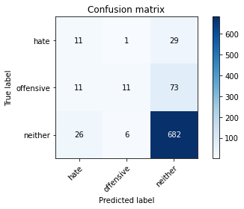

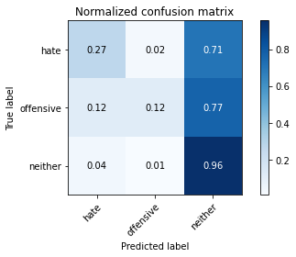

precision recall f1-score support

hate 0.23 0.27 0.25 41

offensive 0.61 0.12 0.19 95

neither 0.87 0.96 0.91 714

accuracy 0.83 850

macro avg 0.57 0.45 0.45 850

weighted avg 0.81 0.83 0.80 850

average eval_loss: 0.523908615805382, accuracy: 0.8282352941176471

training 5 epoch...

10.605270147323608 seconds used......

5 training finished! average train loss: 0.1525823715214546

evaluating...

Confusion matrix, without normalization

[[ 7 9 25]

[ 11 49 35]

[ 26 95 593]]

Normalized confusion matrix

[[0.17073171 0.2195122 0.6097561 ]

[0.11578947 0.51578947 0.36842105]

[0.03641457 0.13305322 0.83053221]]

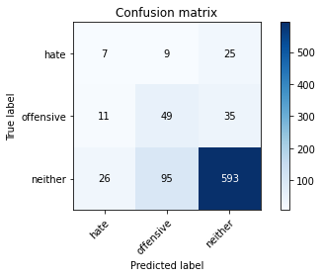

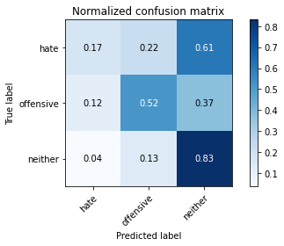

precision recall f1-score support

hate 0.16 0.17 0.16 41

offensive 0.32 0.52 0.40 95

neither 0.91 0.83 0.87 714

accuracy 0.76 850

macro avg 0.46 0.51 0.48 850

weighted avg 0.81 0.76 0.78 850

average eval_loss: 0.6836665729169062, accuracy: 0.7635294117647059

training 6 epoch...

10.593794822692871 seconds used......

6 training finished! average train loss: 0.06278672917531086

evaluating...

Confusion matrix, without normalization

[[ 7 8 26]

[ 7 40 48]

[ 22 84 608]]

Normalized confusion matrix

[[0.17073171 0.19512195 0.63414634]

[0.07368421 0.42105263 0.50526316]

[0.03081232 0.11764706 0.85154062]]

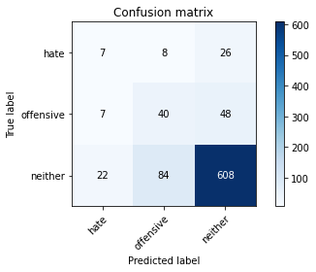

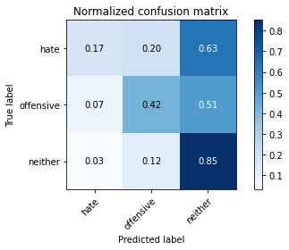

precision recall f1-score support

hate 0.19 0.17 0.18 41

offensive 0.30 0.42 0.35 95

neither 0.89 0.85 0.87 714

accuracy 0.77 850

macro avg 0.46 0.48 0.47 850

weighted avg 0.79 0.77 0.78 850

average eval_loss: 0.7823187306409615, accuracy: 0.7705882352941177

training 7 epoch...

10.547298431396484 seconds used......

7 training finished! average train loss: 0.026972114083428797

evaluating...

Confusion matrix, without normalization

[[ 5 12 24]

[ 7 57 31]

[ 13 115 586]]

Normalized confusion matrix

[[0.12195122 0.29268293 0.58536585]

[0.07368421 0.6 0.32631579]

[0.01820728 0.16106443 0.82072829]]

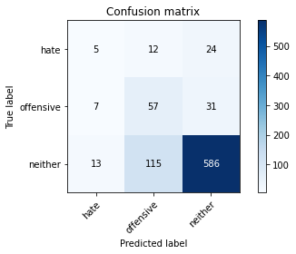

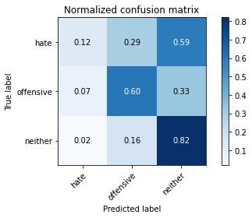

precision recall f1-score support

hate 0.20 0.12 0.15 41

offensive 0.31 0.60 0.41 95

neither 0.91 0.82 0.86 714

accuracy 0.76 850

macro avg 0.47 0.51 0.48 850

weighted avg 0.81 0.76 0.78 850

average eval_loss: 0.9389242455200834, accuracy: 0.7623529411764706

training 8 epoch...

10.588094234466553 seconds used......

8 training finished! average train loss: 0.020097895057943578

evaluating...

Confusion matrix, without normalization

[[ 5 5 31]

[ 5 17 73]

[ 18 53 643]]

Normalized confusion matrix

[[0.12195122 0.12195122 0.75609756]

[0.05263158 0.17894737 0.76842105]

[0.02521008 0.07422969 0.90056022]]

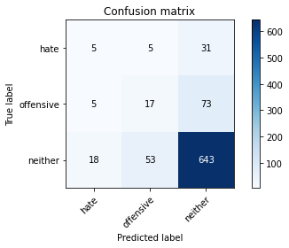

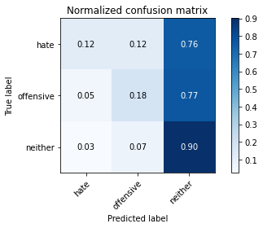

precision recall f1-score support

hate 0.18 0.12 0.14 41

offensive 0.23 0.18 0.20 95

neither 0.86 0.90 0.88 714

accuracy 0.78 850

macro avg 0.42 0.40 0.41 850

weighted avg 0.76 0.78 0.77 850

average eval_loss: 0.9503090853524004, accuracy: 0.7823529411764706

training 9 epoch...

10.556325197219849 seconds used......

9 training finished! average train loss: 0.010582215962215112

evaluating...

Confusion matrix, without normalization

[[ 4 8 29]

[ 4 23 68]

[ 9 43 662]]

Normalized confusion matrix

[[0.09756098 0.19512195 0.70731707]

[0.04210526 0.24210526 0.71578947]

[0.01260504 0.06022409 0.92717087]]

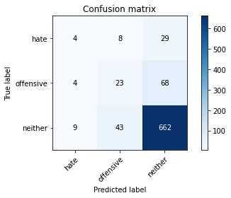

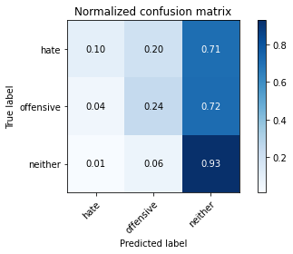

precision recall f1-score support

hate 0.24 0.10 0.14 41

offensive 0.31 0.24 0.27 95

neither 0.87 0.93 0.90 714

accuracy 0.81 850

macro avg 0.47 0.42 0.44 850

weighted avg 0.78 0.81 0.79 850

average eval_loss: 0.9214305220713953, accuracy: 0.8105882352941176

training 10 epoch...

10.59990119934082 seconds used......

10 training finished! average train loss: 0.02050236734884003

evaluating...

Confusion matrix, without normalization

[[ 7 20 14]

[ 10 60 25]

[ 26 184 504]]

Normalized confusion matrix

[[0.17073171 0.48780488 0.34146341]

[0.10526316 0.63157895 0.26315789]

[0.03641457 0.25770308 0.70588235]]

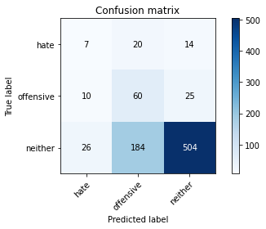

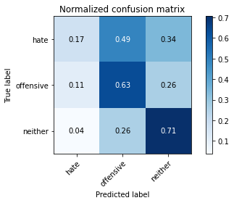

precision recall f1-score support

hate 0.16 0.17 0.17 41

offensive 0.23 0.63 0.33 95

neither 0.93 0.71 0.80 714

accuracy 0.67 850

macro avg 0.44 0.50 0.43 850

weighted avg 0.81 0.67 0.72 850

average eval_loss: 1.413441451055236, accuracy: 0.6717647058823529

training 11 epoch...

10.540304183959961 seconds used......

11 training finished! average train loss: 0.03854594416379069

evaluating...

Confusion matrix, without normalization

[[ 8 5 28]

[ 7 33 55]

[ 22 41 651]]

Normalized confusion matrix

[[0.19512195 0.12195122 0.68292683]

[0.07368421 0.34736842 0.57894737]

[0.03081232 0.05742297 0.91176471]]

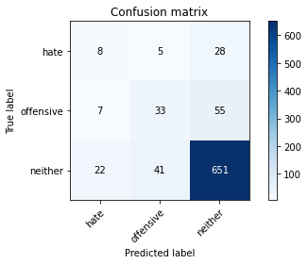

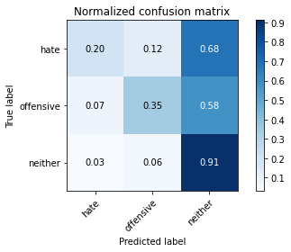

precision recall f1-score support

hate 0.22 0.20 0.21 41

offensive 0.42 0.35 0.38 95

neither 0.89 0.91 0.90 714

accuracy 0.81 850

macro avg 0.51 0.48 0.49 850

weighted avg 0.80 0.81 0.81 850

average eval_loss: 0.8395937136712831, accuracy: 0.8141176470588235

training 12 epoch...

10.549846172332764 seconds used......

12 training finished! average train loss: 0.006136025980902979

evaluating...

Confusion matrix, without normalization

[[ 5 9 27]

[ 7 45 43]

[ 17 95 602]]

Normalized confusion matrix

[[0.12195122 0.2195122 0.65853659]

[0.07368421 0.47368421 0.45263158]

[0.02380952 0.13305322 0.84313725]]

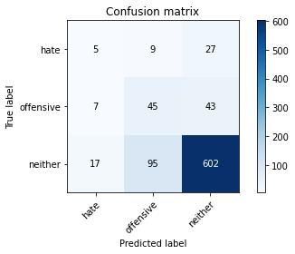

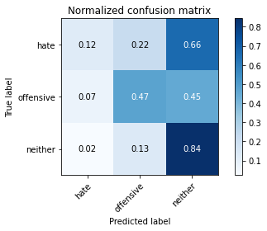

precision recall f1-score support

hate 0.17 0.12 0.14 41

offensive 0.30 0.47 0.37 95

neither 0.90 0.84 0.87 714

accuracy 0.77 850

macro avg 0.46 0.48 0.46 850

weighted avg 0.79 0.77 0.78 850

average eval_loss: 0.9547122500411798, accuracy: 0.7670588235294118

training 13 epoch...

10.595771551132202 seconds used......

13 training finished! average train loss: 0.0026740239655527356

evaluating...

Confusion matrix, without normalization

[[ 5 9 27]

[ 6 43 46]

[ 14 81 619]]

Normalized confusion matrix

[[0.12195122 0.2195122 0.65853659]

[0.06315789 0.45263158 0.48421053]

[0.01960784 0.11344538 0.86694678]]

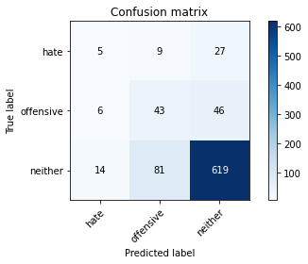

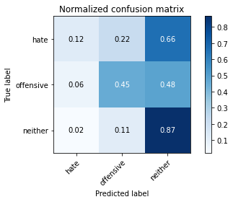

precision recall f1-score support

hate 0.20 0.12 0.15 41

offensive 0.32 0.45 0.38 95

neither 0.89 0.87 0.88 714

accuracy 0.78 850

macro avg 0.47 0.48 0.47 850

weighted avg 0.80 0.78 0.79 850

average eval_loss: 0.9551408338221061, accuracy: 0.7847058823529411

training 14 epoch...

10.527482986450195 seconds used......

14 training finished! average train loss: 0.0016193821041200023

evaluating...

Confusion matrix, without normalization

[[ 5 8 28]

[ 7 34 54]

[ 14 64 636]]

Normalized confusion matrix

[[0.12195122 0.19512195 0.68292683]

[0.07368421 0.35789474 0.56842105]

[0.01960784 0.08963585 0.8907563 ]]

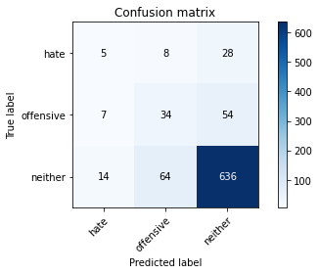

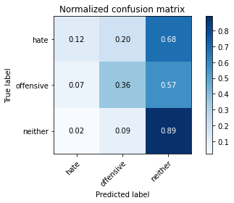

precision recall f1-score support

hate 0.19 0.12 0.15 41

offensive 0.32 0.36 0.34 95

neither 0.89 0.89 0.89 714

accuracy 0.79 850

macro avg 0.47 0.46 0.46 850

weighted avg 0.79 0.79 0.79 850

average eval_loss: 0.9963882647740362, accuracy: 0.7941176470588235

training 15 epoch...

10.608304738998413 seconds used......

15 training finished! average train loss: 0.0013692713270966822

evaluating...

Confusion matrix, without normalization

[[ 5 9 27]

[ 7 38 50]

[ 15 81 618]]

Normalized confusion matrix

[[0.12195122 0.2195122 0.65853659]

[0.07368421 0.4 0.52631579]

[0.0210084 0.11344538 0.86554622]]

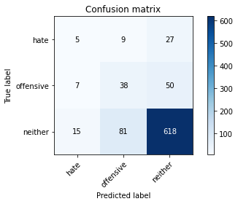

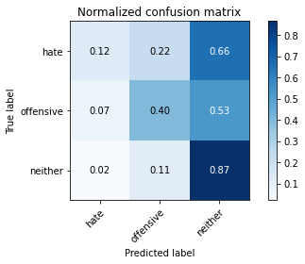

precision recall f1-score support

hate 0.19 0.12 0.15 41

offensive 0.30 0.40 0.34 95

neither 0.89 0.87 0.88 714

accuracy 0.78 850

macro avg 0.46 0.46 0.46 850

weighted avg 0.79 0.78 0.78 850

average eval_loss: 1.065754193300246, accuracy: 0.7776470588235294

training 16 epoch...

10.53267216682434 seconds used......

16 training finished! average train loss: 0.0008461608392490934

evaluating...

Confusion matrix, without normalization

[[ 5 9 27]

[ 7 40 48]

[ 16 87 611]]

Normalized confusion matrix

[[0.12195122 0.2195122 0.65853659]

[0.07368421 0.42105263 0.50526316]

[0.02240896 0.12184874 0.8557423 ]]

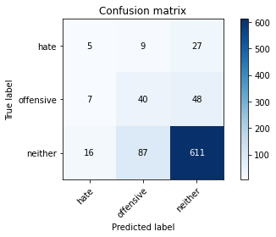

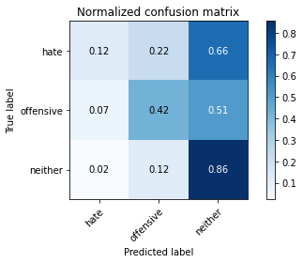

precision recall f1-score support

hate 0.18 0.12 0.14 41

offensive 0.29 0.42 0.35 95

neither 0.89 0.86 0.87 714

accuracy 0.77 850

macro avg 0.45 0.47 0.45 850

weighted avg 0.79 0.77 0.78 850

average eval_loss: 1.1095420268961895, accuracy: 0.7717647058823529

training 17 epoch...

10.594085931777954 seconds used......

17 training finished! average train loss: 0.0007077256658633884

evaluating...

Confusion matrix, without normalization

[[ 5 9 27]

[ 7 39 49]

[ 16 86 612]]

Normalized confusion matrix

[[0.12195122 0.2195122 0.65853659]

[0.07368421 0.41052632 0.51578947]

[0.02240896 0.12044818 0.85714286]]

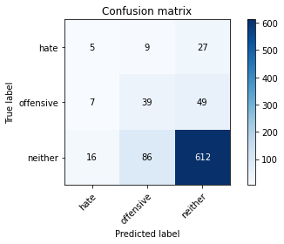

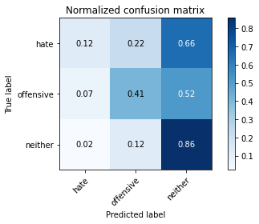

precision recall f1-score support

hate 0.18 0.12 0.14 41

offensive 0.29 0.41 0.34 95

neither 0.89 0.86 0.87 714

accuracy 0.77 850

macro avg 0.45 0.46 0.45 850

weighted avg 0.79 0.77 0.78 850

average eval_loss: 1.1211725438983575, accuracy: 0.7717647058823529

training 18 epoch...

10.55495548248291 seconds used......

18 training finished! average train loss: 0.000805424788268283

evaluating...

Confusion matrix, without normalization

[[ 5 9 27]

[ 6 40 49]

[ 13 85 616]]

Normalized confusion matrix

[[0.12195122 0.2195122 0.65853659]

[0.06315789 0.42105263 0.51578947]

[0.01820728 0.11904762 0.8627451 ]]

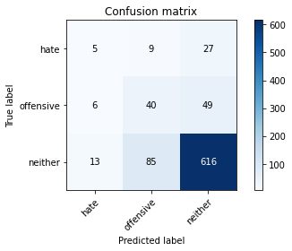

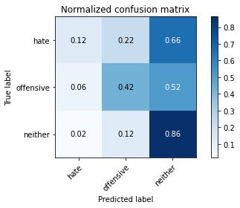

precision recall f1-score support

hate 0.21 0.12 0.15 41

offensive 0.30 0.42 0.35 95

neither 0.89 0.86 0.88 714

accuracy 0.78 850

macro avg 0.47 0.47 0.46 850

weighted avg 0.79 0.78 0.78 850

average eval_loss: 1.1412196770157437, accuracy: 0.7776470588235294

training 19 epoch...

10.524457216262817 seconds used......

19 training finished! average train loss: 0.0005994143656257969

evaluating...

Confusion matrix, without normalization

[[ 5 9 27]

[ 5 43 47]

[ 12 90 612]]

Normalized confusion matrix

[[0.12195122 0.2195122 0.65853659]

[0.05263158 0.45263158 0.49473684]

[0.01680672 0.12605042 0.85714286]]

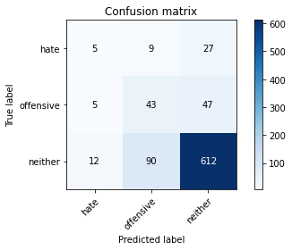

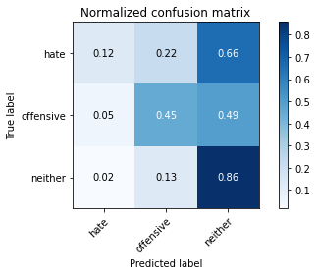

precision recall f1-score support

hate 0.23 0.12 0.16 41

offensive 0.30 0.45 0.36 95

neither 0.89 0.86 0.87 714

accuracy 0.78 850

macro avg 0.47 0.48 0.47 850

weighted avg 0.79 0.78 0.78 850

average eval_loss: 1.1841214425028654, accuracy: 0.7764705882352941

training 20 epoch...

10.530218362808228 seconds used......

20 training finished! average train loss: 0.0006999320646103185

evaluating...

Confusion matrix, without normalization

[[ 5 9 27]

[ 5 39 51]

[ 12 79 623]]

Normalized confusion matrix

[[0.12195122 0.2195122 0.65853659]

[0.05263158 0.41052632 0.53684211]

[0.01680672 0.11064426 0.87254902]]

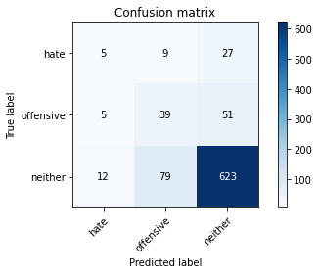

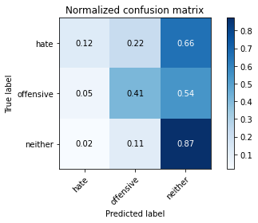

precision recall f1-score support

hate 0.23 0.12 0.16 41

offensive 0.31 0.41 0.35 95

neither 0.89 0.87 0.88 714

accuracy 0.78 850

macro avg 0.47 0.47 0.46 850

weighted avg 0.79 0.78 0.79 850

average eval_loss: 1.1544351796298098, accuracy: 0.7847058823529411

5 run......

training 1 epoch...

10.57014799118042 seconds used......

1 training finished! average train loss: 0.7546381111328418

evaluating...

Confusion matrix, without normalization

[[ 0 0 41]

[ 0 0 95]

[ 0 0 714]]

Normalized confusion matrix

[[0. 0. 1.]

[0. 0. 1.]

[0. 0. 1.]]





/opt/conda/lib/python3.7/site-packages/sklearn/metrics/_classification.py:1245: UndefinedMetricWarning: Precision and F-score are ill-defined and being set to 0.0 in labels with no predicted samples. Use `zero_division` parameter to control this behavior.

_warn_prf(average, modifier, msg_start, len(result))

/opt/conda/lib/python3.7/site-packages/sklearn/metrics/_classification.py:1245: UndefinedMetricWarning: Precision and F-score are ill-defined and being set to 0.0 in labels with no predicted samples. Use `zero_division` parameter to control this behavior.

_warn_prf(average, modifier, msg_start, len(result))

/opt/conda/lib/python3.7/site-packages/sklearn/metrics/_classification.py:1245: UndefinedMetricWarning: Precision and F-score are ill-defined and being set to 0.0 in labels with no predicted samples. Use `zero_division` parameter to control this behavior.

_warn_prf(average, modifier, msg_start, len(result))

precision recall f1-score support

hate 0.00 0.00 0.00 41

offensive 0.00 0.00 0.00 95

neither 0.84 1.00 0.91 714

accuracy 0.84 850

macro avg 0.28 0.33 0.30 850

weighted avg 0.71 0.84 0.77 850

average eval_loss: 0.5944301066703574, accuracy: 0.84

training 2 epoch...

10.531168699264526 seconds used......

2 training finished! average train loss: 0.6688481743519122

evaluating...

Confusion matrix, without normalization

[[ 3 0 38]

[ 2 0 93]

[ 7 3 704]]

Normalized confusion matrix

[[0.07317073 0. 0.92682927]

[0.02105263 0. 0.97894737]

[0.00980392 0.00420168 0.9859944 ]]

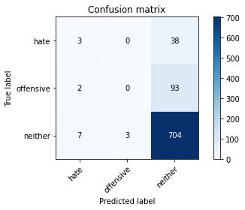

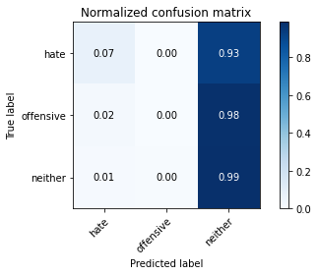

precision recall f1-score support

hate 0.25 0.07 0.11 41

offensive 0.00 0.00 0.00 95

neither 0.84 0.99 0.91 714

accuracy 0.83 850

macro avg 0.36 0.35 0.34 850

weighted avg 0.72 0.83 0.77 850

average eval_loss: 0.5255516705991223, accuracy: 0.831764705882353

training 3 epoch...

10.53683853149414 seconds used......

3 training finished! average train loss: 0.5348612379569274

evaluating...

Confusion matrix, without normalization

[[ 6 0 35]

[ 4 0 91]

[ 13 1 700]]

Normalized confusion matrix

[[0.14634146 0. 0.85365854]

[0.04210526 0. 0.95789474]

[0.01820728 0.00140056 0.98039216]]

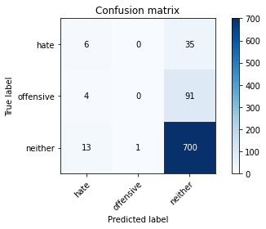

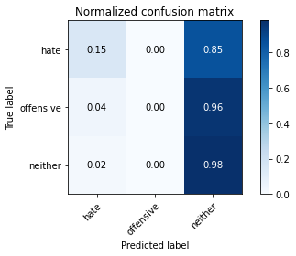

precision recall f1-score support

hate 0.26 0.15 0.19 41

offensive 0.00 0.00 0.00 95

neither 0.85 0.98 0.91 714

accuracy 0.83 850

macro avg 0.37 0.38 0.37 850

weighted avg 0.72 0.83 0.77 850

average eval_loss: 0.48323124876722345, accuracy: 0.8305882352941176

training 4 epoch...

10.60837721824646 seconds used......

4 training finished! average train loss: 0.3418115641062076

evaluating...

Confusion matrix, without normalization

[[ 14 0 27]

[ 10 9 76]

[ 35 15 664]]

Normalized confusion matrix

[[0.34146341 0. 0.65853659]

[0.10526316 0.09473684 0.8 ]

[0.04901961 0.0210084 0.92997199]]

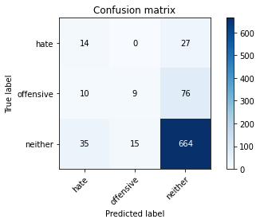

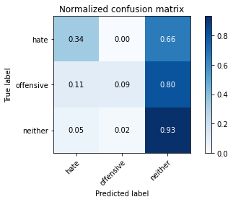

precision recall f1-score support

hate 0.24 0.34 0.28 41

offensive 0.38 0.09 0.15 95

neither 0.87 0.93 0.90 714

accuracy 0.81 850

macro avg 0.49 0.46 0.44 850

weighted avg 0.78 0.81 0.78 850

average eval_loss: 0.4857002575556899, accuracy: 0.808235294117647

training 5 epoch...

10.54274296760559 seconds used......

5 training finished! average train loss: 0.17598940071005087

evaluating...

Confusion matrix, without normalization

[[ 7 6 28]

[ 4 19 72]

[ 13 44 657]]

Normalized confusion matrix

[[0.17073171 0.14634146 0.68292683]

[0.04210526 0.2 0.75789474]

[0.01820728 0.06162465 0.92016807]]

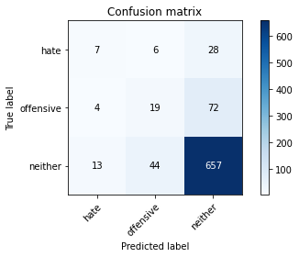

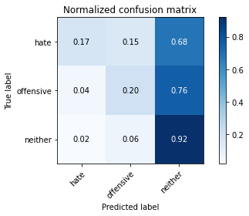

precision recall f1-score support

hate 0.29 0.17 0.22 41

offensive 0.28 0.20 0.23 95

neither 0.87 0.92 0.89 714

accuracy 0.80 850

macro avg 0.48 0.43 0.45 850

weighted avg 0.77 0.80 0.79 850

average eval_loss: 0.6065094666988697, accuracy: 0.8035294117647059

training 6 epoch...

10.588436365127563 seconds used......

6 training finished! average train loss: 0.07250975975050376

evaluating...

Confusion matrix, without normalization

[[ 9 9 23]

[ 7 29 59]

[ 29 78 607]]

Normalized confusion matrix

[[0.2195122 0.2195122 0.56097561]

[0.07368421 0.30526316 0.62105263]

[0.04061625 0.1092437 0.85014006]]

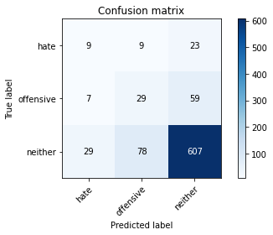

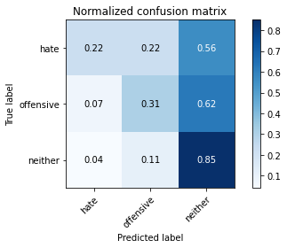

precision recall f1-score support

hate 0.20 0.22 0.21 41

offensive 0.25 0.31 0.27 95

neither 0.88 0.85 0.87 714

accuracy 0.76 850

macro avg 0.44 0.46 0.45 850

weighted avg 0.78 0.76 0.77 850

average eval_loss: 0.7386866752816321, accuracy: 0.7588235294117647

training 7 epoch...

10.523497104644775 seconds used......

7 training finished! average train loss: 0.027471543963138875

evaluating...

Confusion matrix, without normalization

[[ 10 12 19]

[ 6 43 46]

[ 24 111 579]]

Normalized confusion matrix

[[0.24390244 0.29268293 0.46341463]

[0.06315789 0.45263158 0.48421053]

[0.03361345 0.15546218 0.81092437]]

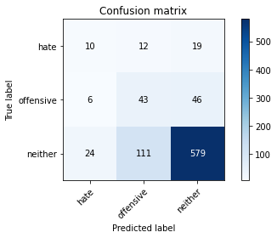

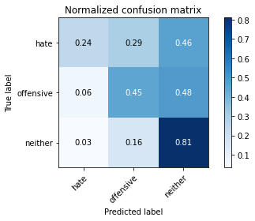

precision recall f1-score support

hate 0.25 0.24 0.25 41

offensive 0.26 0.45 0.33 95

neither 0.90 0.81 0.85 714

accuracy 0.74 850

macro avg 0.47 0.50 0.48 850

weighted avg 0.80 0.74 0.77 850

average eval_loss: 0.8797000513931866, accuracy: 0.7435294117647059

training 8 epoch...

10.58631420135498 seconds used......

8 training finished! average train loss: 0.020752874638240496

evaluating...

Confusion matrix, without normalization

[[ 10 14 17]

[ 7 32 56]

[ 30 101 583]]

Normalized confusion matrix

[[0.24390244 0.34146341 0.41463415]

[0.07368421 0.33684211 0.58947368]

[0.04201681 0.14145658 0.81652661]]

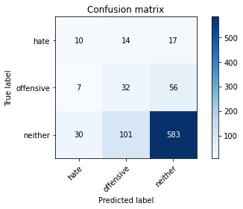

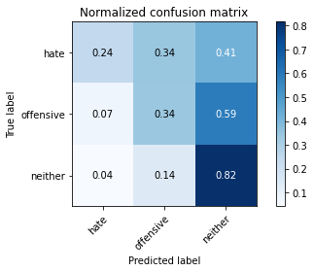

precision recall f1-score support

hate 0.21 0.24 0.23 41

offensive 0.22 0.34 0.26 95

neither 0.89 0.82 0.85 714

accuracy 0.74 850

macro avg 0.44 0.47 0.45 850

weighted avg 0.78 0.74 0.76 850

average eval_loss: 0.9953701635335334, accuracy: 0.7352941176470589

training 9 epoch...

10.527357816696167 seconds used......

9 training finished! average train loss: 0.010473360063937995

evaluating...

Confusion matrix, without normalization

[[ 7 15 19]

[ 5 35 55]

[ 27 113 574]]

Normalized confusion matrix

[[0.17073171 0.36585366 0.46341463]

[0.05263158 0.36842105 0.57894737]

[0.03781513 0.15826331 0.80392157]]

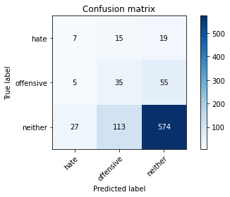

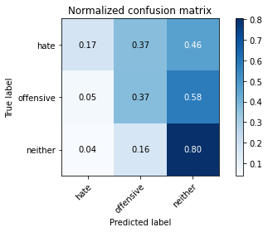

precision recall f1-score support

hate 0.18 0.17 0.18 41

offensive 0.21 0.37 0.27 95

neither 0.89 0.80 0.84 714

accuracy 0.72 850

macro avg 0.43 0.45 0.43 850

weighted avg 0.78 0.72 0.75 850

average eval_loss: 1.0878198128139471, accuracy: 0.7247058823529412

training 10 epoch...

10.547090768814087 seconds used......

10 training finished! average train loss: 0.005291041146175793

evaluating...

Confusion matrix, without normalization

[[ 2 11 28]

[ 4 19 72]

[ 15 72 627]]

Normalized confusion matrix

[[0.04878049 0.26829268 0.68292683]

[0.04210526 0.2 0.75789474]

[0.0210084 0.10084034 0.87815126]]

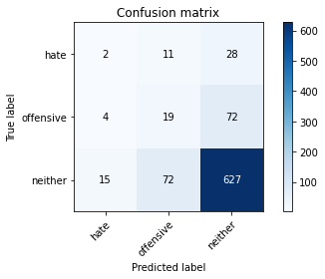

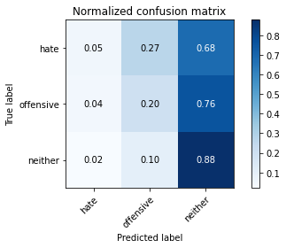

precision recall f1-score support

hate 0.10 0.05 0.06 41

offensive 0.19 0.20 0.19 95

neither 0.86 0.88 0.87 714

accuracy 0.76 850

macro avg 0.38 0.38 0.38 850

weighted avg 0.75 0.76 0.76 850

average eval_loss: 1.0311064814186255, accuracy: 0.7623529411764706

training 11 epoch...

10.541016340255737 seconds used......

11 training finished! average train loss: 0.002791098604659335

evaluating...

Confusion matrix, without normalization

[[ 3 11 27]

[ 4 26 65]

[ 13 85 616]]

Normalized confusion matrix

[[0.07317073 0.26829268 0.65853659]

[0.04210526 0.27368421 0.68421053]

[0.01820728 0.11904762 0.8627451 ]]

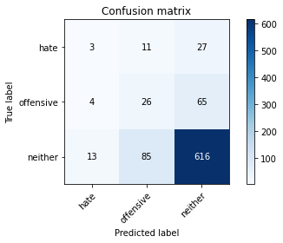

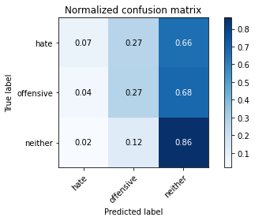

precision recall f1-score support

hate 0.15 0.07 0.10 41

offensive 0.21 0.27 0.24 95

neither 0.87 0.86 0.87 714

accuracy 0.76 850

macro avg 0.41 0.40 0.40 850

weighted avg 0.76 0.76 0.76 850

average eval_loss: 1.0826536338731678, accuracy: 0.7588235294117647

training 12 epoch...

10.53788948059082 seconds used......

12 training finished! average train loss: 0.0013675633674630752

evaluating...

Confusion matrix, without normalization

[[ 2 10 29]

[ 5 19 71]

[ 16 71 627]]

Normalized confusion matrix

[[0.04878049 0.24390244 0.70731707]

[0.05263158 0.2 0.74736842]

[0.02240896 0.09943978 0.87815126]]

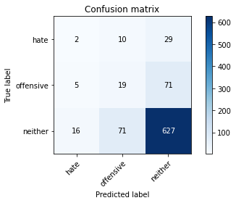

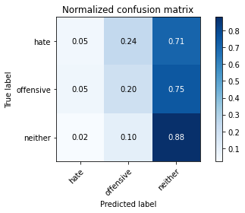

precision recall f1-score support

hate 0.09 0.05 0.06 41

offensive 0.19 0.20 0.19 95

neither 0.86 0.88 0.87 714

accuracy 0.76 850

macro avg 0.38 0.38 0.38 850

weighted avg 0.75 0.76 0.76 850

average eval_loss: 1.08536923031301, accuracy: 0.7623529411764706

training 13 epoch...

10.585193157196045 seconds used......

13 training finished! average train loss: 0.0031421029559658984

evaluating...

Confusion matrix, without normalization

[[ 3 9 29]

[ 5 11 79]

[ 13 35 666]]

Normalized confusion matrix

[[0.07317073 0.2195122 0.70731707]

[0.05263158 0.11578947 0.83157895]

[0.01820728 0.04901961 0.93277311]]

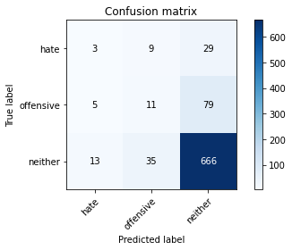

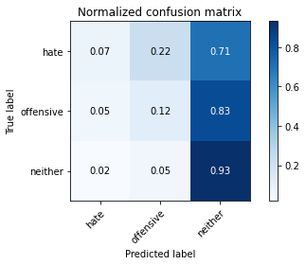

precision recall f1-score support

hate 0.14 0.07 0.10 41

offensive 0.20 0.12 0.15 95

neither 0.86 0.93 0.90 714

accuracy 0.80 850

macro avg 0.40 0.37 0.38 850

weighted avg 0.75 0.80 0.77 850

average eval_loss: 1.1359332754854707, accuracy: 0.8

training 14 epoch...

10.574501276016235 seconds used......

14 training finished! average train loss: 0.004255101427238865

evaluating...

Confusion matrix, without normalization

[[ 9 5 27]

[ 7 25 63]

[ 36 60 618]]

Normalized confusion matrix

[[0.2195122 0.12195122 0.65853659]

[0.07368421 0.26315789 0.66315789]

[0.05042017 0.08403361 0.86554622]]

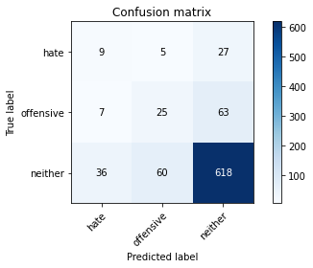

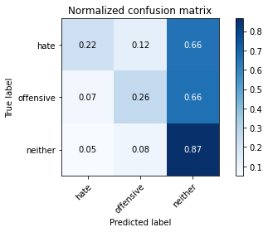

precision recall f1-score support

hate 0.17 0.22 0.19 41

offensive 0.28 0.26 0.27 95

neither 0.87 0.87 0.87 714

accuracy 0.77 850

macro avg 0.44 0.45 0.44 850

weighted avg 0.77 0.77 0.77 850

average eval_loss: 1.1218752564881322, accuracy: 0.7670588235294118

training 15 epoch...

10.599617719650269 seconds used......

15 training finished! average train loss: 0.01763134218277768

evaluating...

Confusion matrix, without normalization

[[ 0 7 34]

[ 3 19 73]

[ 5 62 647]]

Normalized confusion matrix

[[0. 0.17073171 0.82926829]

[0.03157895 0.2 0.76842105]

[0.0070028 0.08683473 0.90616246]]

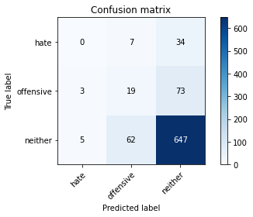

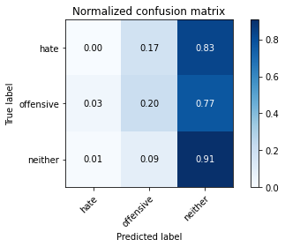

precision recall f1-score support

hate 0.00 0.00 0.00 41

offensive 0.22 0.20 0.21 95

neither 0.86 0.91 0.88 714

accuracy 0.78 850

macro avg 0.36 0.37 0.36 850

weighted avg 0.74 0.78 0.76 850

average eval_loss: 1.1680989588697464, accuracy: 0.7835294117647059

training 16 epoch...

10.507786750793457 seconds used......

16 training finished! average train loss: 0.007430585619071141

evaluating...

Confusion matrix, without normalization

[[ 6 8 27]

[ 3 28 64]

[ 13 74 627]]

Normalized confusion matrix

[[0.14634146 0.19512195 0.65853659]

[0.03157895 0.29473684 0.67368421]

[0.01820728 0.10364146 0.87815126]]

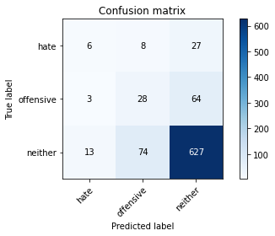

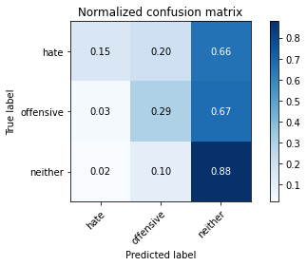

precision recall f1-score support

hate 0.27 0.15 0.19 41

offensive 0.25 0.29 0.27 95

neither 0.87 0.88 0.88 714

accuracy 0.78 850

macro avg 0.47 0.44 0.45 850

weighted avg 0.78 0.78 0.78 850

average eval_loss: 1.090243770027544, accuracy: 0.7776470588235294

training 17 epoch...

10.617615699768066 seconds used......

17 training finished! average train loss: 0.001336636482917059

evaluating...

Confusion matrix, without normalization

[[ 6 8 27]

[ 3 21 71]

[ 13 68 633]]

Normalized confusion matrix

[[0.14634146 0.19512195 0.65853659]

[0.03157895 0.22105263 0.74736842]

[0.01820728 0.0952381 0.88655462]]

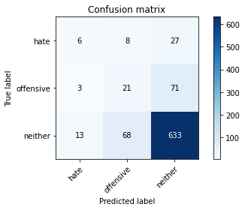

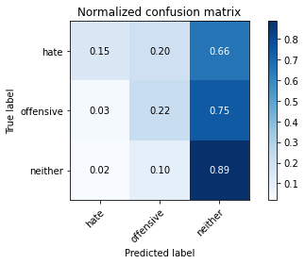

precision recall f1-score support

hate 0.27 0.15 0.19 41

offensive 0.22 0.22 0.22 95

neither 0.87 0.89 0.88 714

accuracy 0.78 850

macro avg 0.45 0.42 0.43 850

weighted avg 0.76 0.78 0.77 850

average eval_loss: 1.131578766406503, accuracy: 0.7764705882352941

training 18 epoch...

10.54078483581543 seconds used......

18 training finished! average train loss: 0.0007490725287845215

evaluating...

Confusion matrix, without normalization

[[ 6 8 27]

[ 3 22 70]

[ 13 71 630]]

Normalized confusion matrix

[[0.14634146 0.19512195 0.65853659]

[0.03157895 0.23157895 0.73684211]

[0.01820728 0.09943978 0.88235294]]

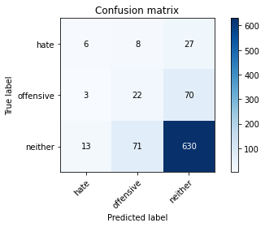

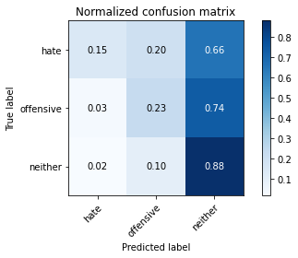

precision recall f1-score support

hate 0.27 0.15 0.19 41

offensive 0.22 0.23 0.22 95

neither 0.87 0.88 0.87 714

accuracy 0.77 850

macro avg 0.45 0.42 0.43 850

weighted avg 0.77 0.77 0.77 850

average eval_loss: 1.1628755292771276, accuracy: 0.7741176470588236

training 19 epoch...

10.551367044448853 seconds used......

19 training finished! average train loss: 0.001586376837356231

evaluating...

Confusion matrix, without normalization

[[ 3 7 31]

[ 3 15 77]

[ 9 51 654]]

Normalized confusion matrix

[[0.07317073 0.17073171 0.75609756]

[0.03157895 0.15789474 0.81052632]

[0.01260504 0.07142857 0.91596639]]

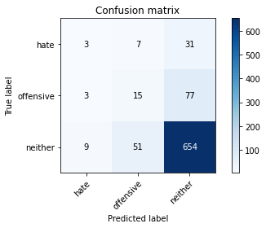

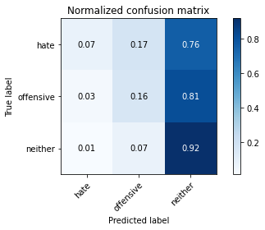

precision recall f1-score support

hate 0.20 0.07 0.11 41

offensive 0.21 0.16 0.18 95

neither 0.86 0.92 0.89 714

accuracy 0.79 850

macro avg 0.42 0.38 0.39 850

weighted avg 0.75 0.79 0.77 850

average eval_loss: 1.1959962467520855, accuracy: 0.7905882352941176

training 20 epoch...

10.53540325164795 seconds used......

20 training finished! average train loss: 0.0010146877932129428

evaluating...

Confusion matrix, without normalization

[[ 6 12 23]

[ 4 32 59]

[ 17 95 602]]

Normalized confusion matrix

[[0.14634146 0.29268293 0.56097561]

[0.04210526 0.33684211 0.62105263]

[0.02380952 0.13305322 0.84313725]]

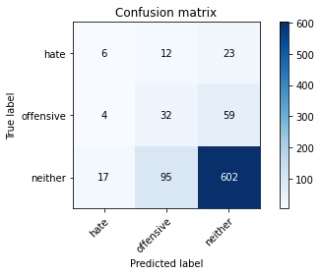

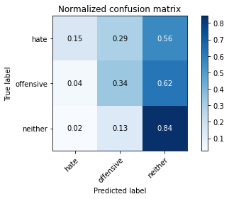

precision recall f1-score support

hate 0.22 0.15 0.18 41

offensive 0.23 0.34 0.27 95

neither 0.88 0.84 0.86 714

accuracy 0.75 850

macro avg 0.44 0.44 0.44 850

weighted avg 0.78 0.75 0.76 850

average eval_loss: 1.260855408986424, accuracy: 0.7529411764705882

add Codeadd Markdown